**PRACTICAL NO:04**

**Using File Recovery Tools [FTK Imager] Creating Image**

**Aim: Understanding & working with the process of the process of taking a drive image using AccessData's FTK Imager tool.**

Step 1) Run **FTK Imager.exe** to start the tool.

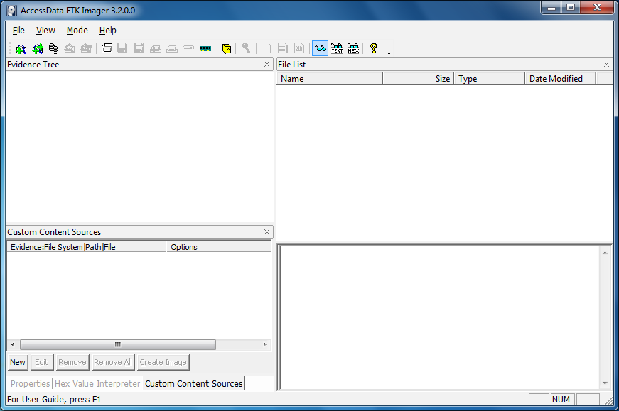

Step 2) To create a forensic image:

Click File > Create Disk Image

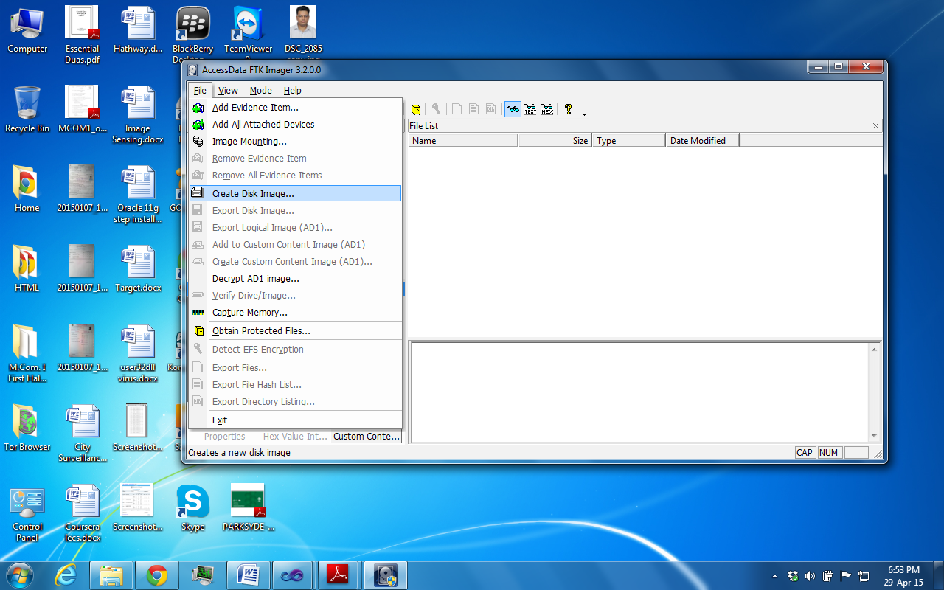

Step 3) In the Select Source dialog box, select the source you want to make an image of. Click Next.

If you select Logical Drive and need to select a floppy or CD as a source, you can check the Automate multiple removable media box to create groups of images. Imager will automatically increment the case numbers with each image, and if something interrupts the process, you may assign case number manually.

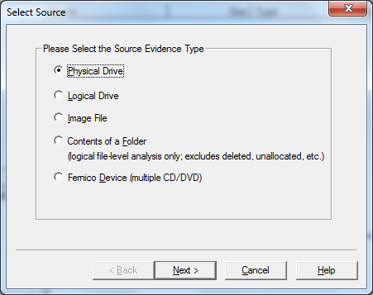

Step 4) Select the drive or browse to the source of the image you want, and then click Finish.

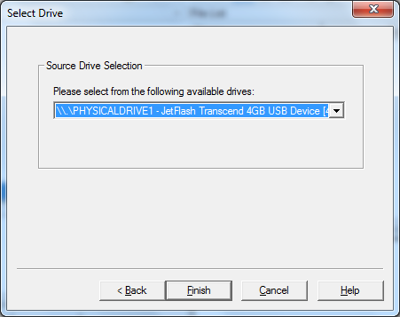

Step 5) In the Create Image dialog, click Add.**...** to add the image destination.

* Compare the stored hashes of your image content by checking the Verify images after they are created box. If a file doesn’t have a hash, this option will generate one.

List the entire contents of your images with path, creation dates, whether files were deleted, and other metadata. The list is saved in tab-separated value (.TSV) format.

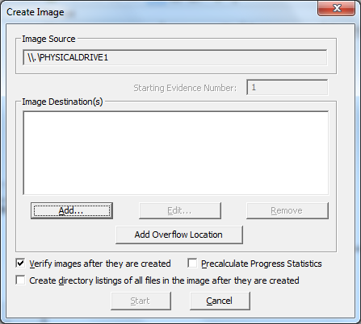

Step 6) Select the type of image you want to create.

The type you choose will usually depend on what tools you plan to use on the image. The dd format will work with more open-source tools, but you might want SMART or E01 if you will primarily be working with ASR Expert Witness or EnCase, respectively.

Note: If you are creating an image of a CD or DVD, this step is skipped because all CD/DVD images are created in the IsoBuster CUE format. Hashes are not generated for CD and DVD images so they will not be verified, as well.

Important: The raw image type is not compressed. If you select the Raw (dd) type, be sure to have adequate available drive space for the resulting image.

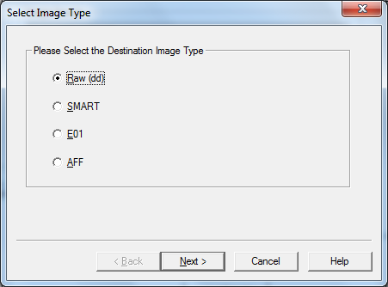

Step 7) If you are creating an AFF image type, choose AFF. Click Next.

The Image Destination Folder dialog box you see will be different than that seen when selecting any other image type

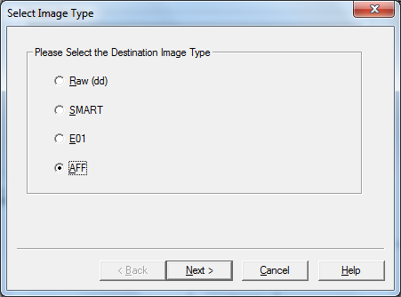

Step 8) If your version of FTK requests evidence information, you can provide it. Specify Evidence Item Information. All Evidence Item Information is optional, but it is helpful to have the information easily accessible in case it is called into question at any time after creation

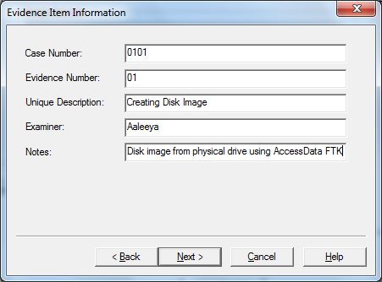

Complete the fields in the Evidence Item Information dialog. Click Next.

Step 9) Select the Image Destination folder and file name. You can also set the maximum fragment size of image split files. Click Finish to complete the wizard.

In the Image Destination Folder field, do one of the following:

* Type the location path where you want to save the image file.
* Click Browse to find and select the desired location.

In the Image Filename field, specify a name for the image file but do not specify a file extension.

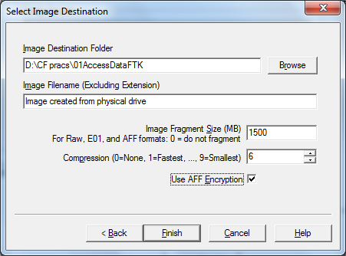

Step 10) Specify the Image fragment Size:

* Default Image Fragment Size = 1500 MB
* To save images segments that can be burned to a CD, specify 650 MB.
* To save image segments that can be burned to a DVD, specify 4000 MB.
* The .S01 format is limited by design to sizes between 1 MB and 2047 MB (2 GB). Compressed block pointers are 31-bit numbers (the high bit is a compressed flag), which limits the size of any one segment to two gigabytes.

Step 10 a) Select the compression level to use.

* 0=No Compression
* 1=Fastest, Least Compression (faster, and also slightly smaller than a 0-compression file)
* 9=Slowest, Most Compression (smallest file, slowest to create).

Numbers between 1 and 9 produce an image with varying levels of compression to speed ratio.

Step 11) To encrypt the image, choose the correct encryption box as explained below:

a. To encrypt the new image with AD Encryption, mark the Use AD Encryption box.

b. To encrypt the new image with AFF Encryption, mark the Use AFF Encryption box.

Step 12) Click Finish.

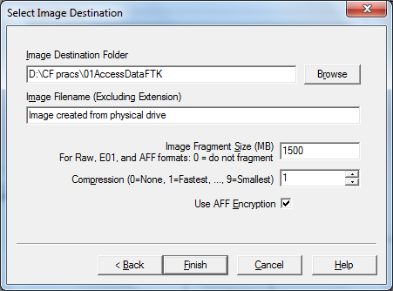

Step 13) When AFF Encryption is selected, type the password, and retype the password to confirm. Click Show Password to see that you have typed it correctly the first time.

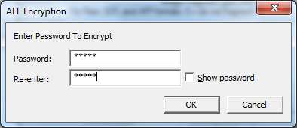

Step 14) When encryption selections are made, click **OK** to save selections and return to the **Create Image dialog.** Click **Start** to begin the imaging process.

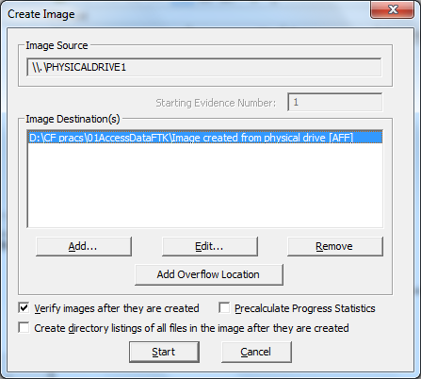

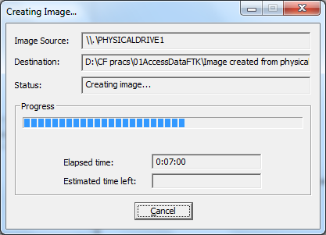

After the images are successfully created, the Drive/Image Verify Results box shows detailed image information, including MD5 and SHA1 check sums, and bad sectors.

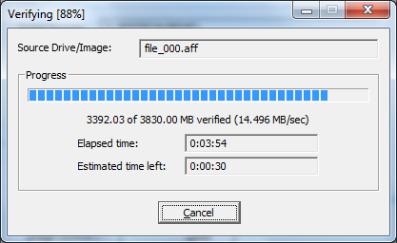

Now is a good time to refill that coffee cup! Once the acquisition is complete, you can view an image summary and the drive will appear in the evidence list in the left-hand side of the main FTK Imager window. You can right-click on the drive name to Verify the Image:

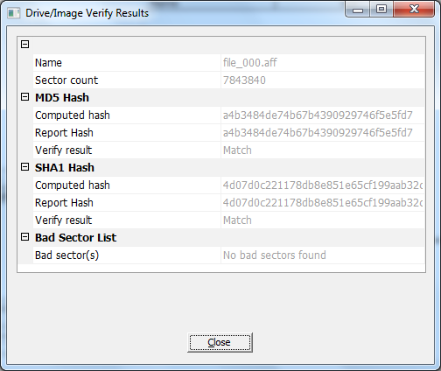

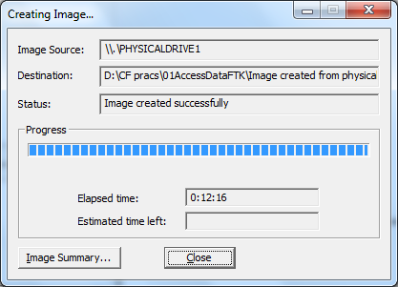

A progress dialog appears that shows the following:

* The source that is being imaged
* The location where the image is being saved
* The status of the imaging process
* A graphical progress bar
* The amount of data in MB that has been copied and the total amount to be copied
* Elapsed time since the imaging process began
* Estimated time remaining until the process is complete
* Image Summary button. Click it to open the Image Summary window as shown below:

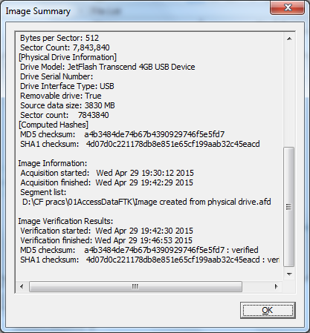

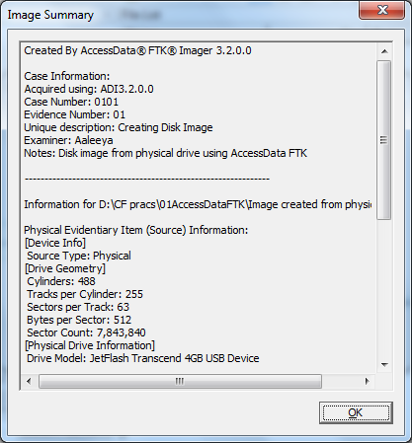

1. **Recover Deleted files using Recuva, PC Inspector File Recovery, Recover My Files**

**Recuva**

Download and install **Recuva**

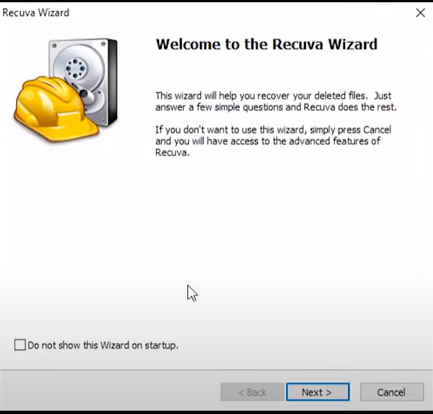

Select File Type you need to recover

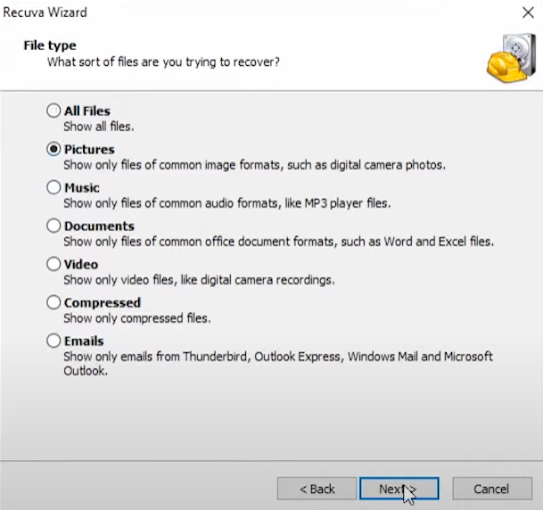

Select File location, which you want to recover files

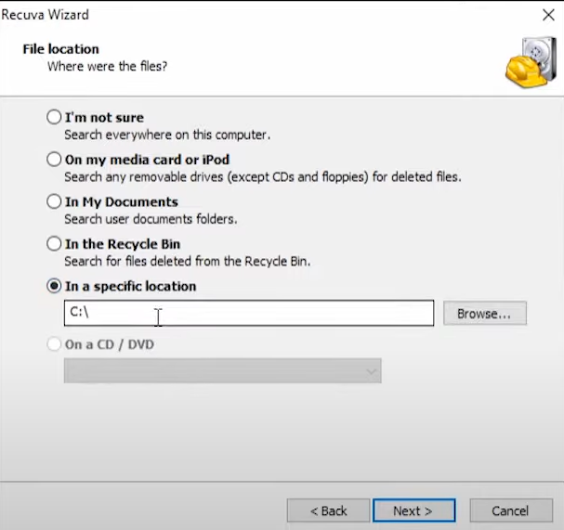

Click next (If want enable Deep Scan)

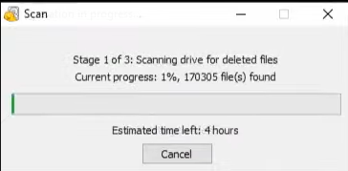

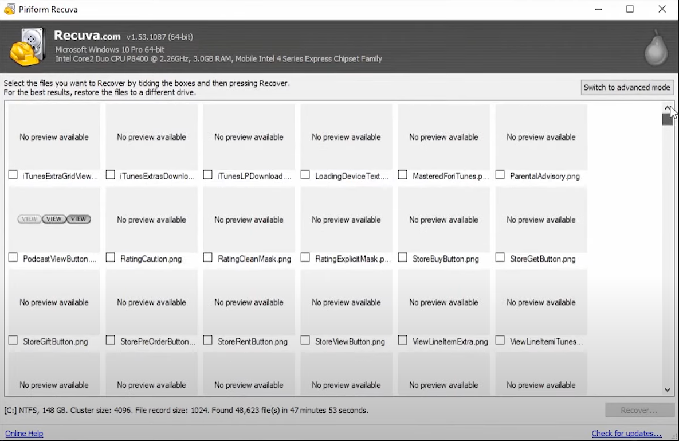

Switch to advanced mode and select all recover file

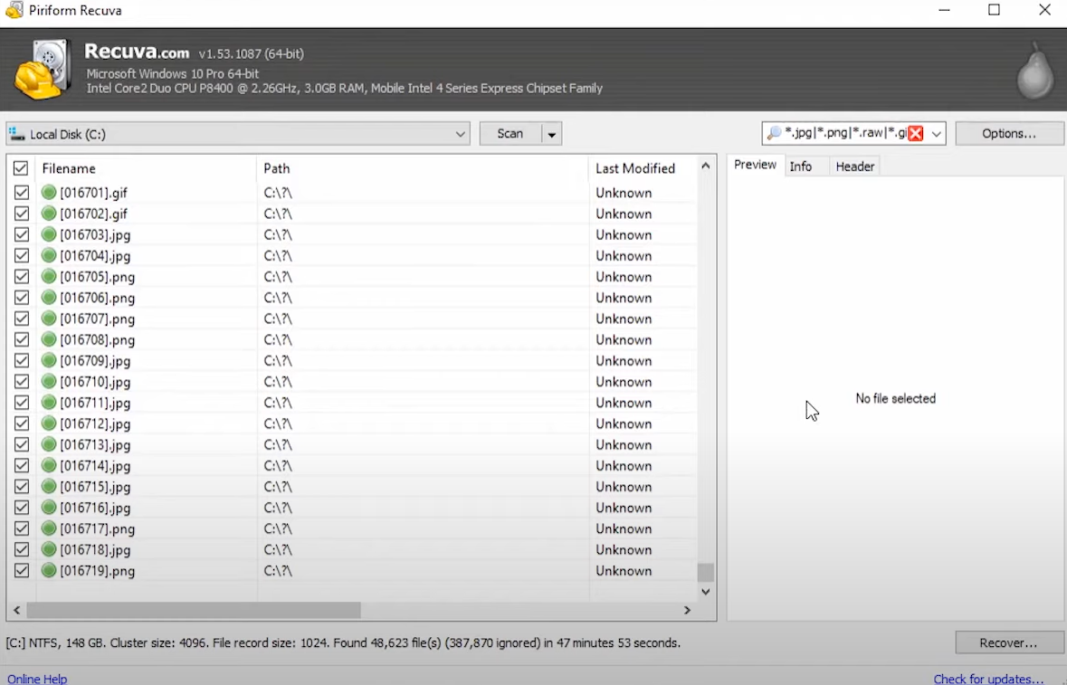Select the location were to recover the file

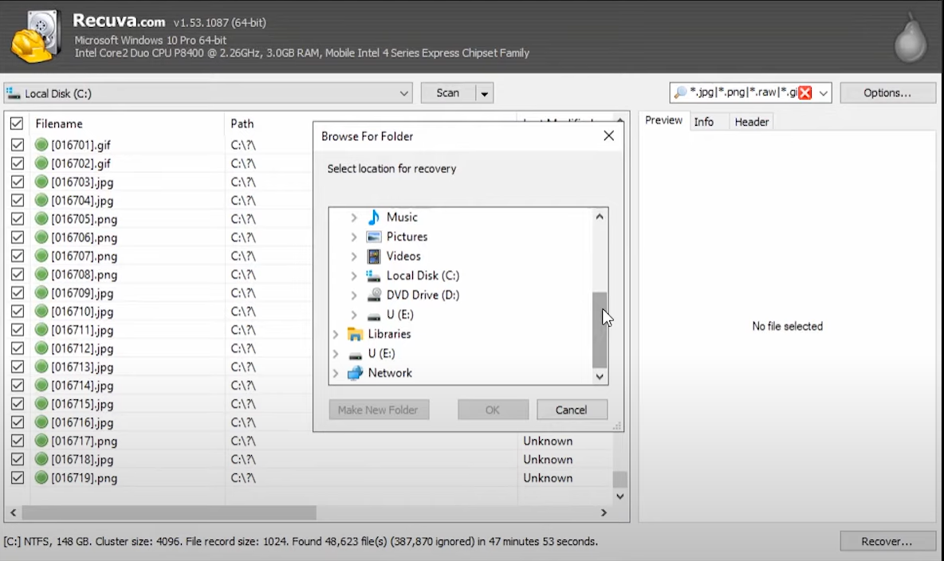

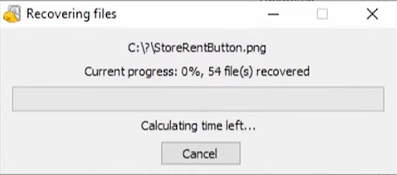

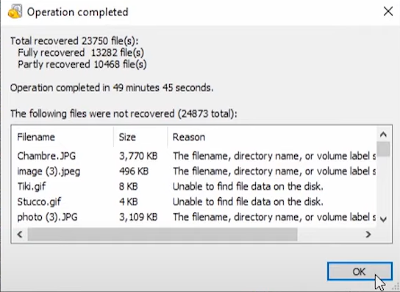

All deleted Files are recovered at specified location

**PC Inspector File Recovery**

Download and install **PC Inspector File Recovery**

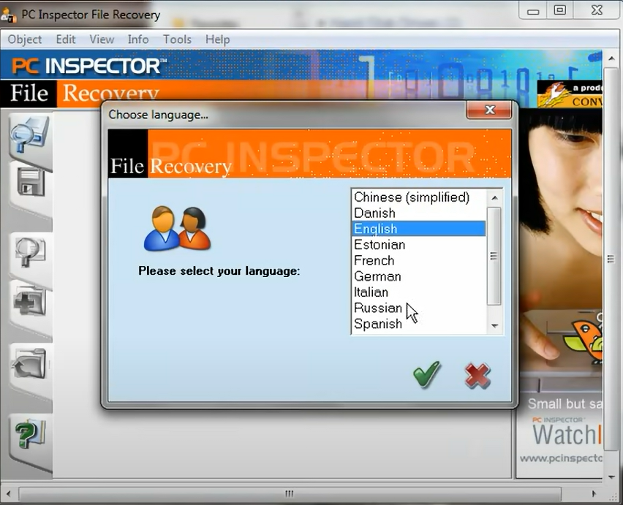

Choose what to recover delete files, lost data or lost drive

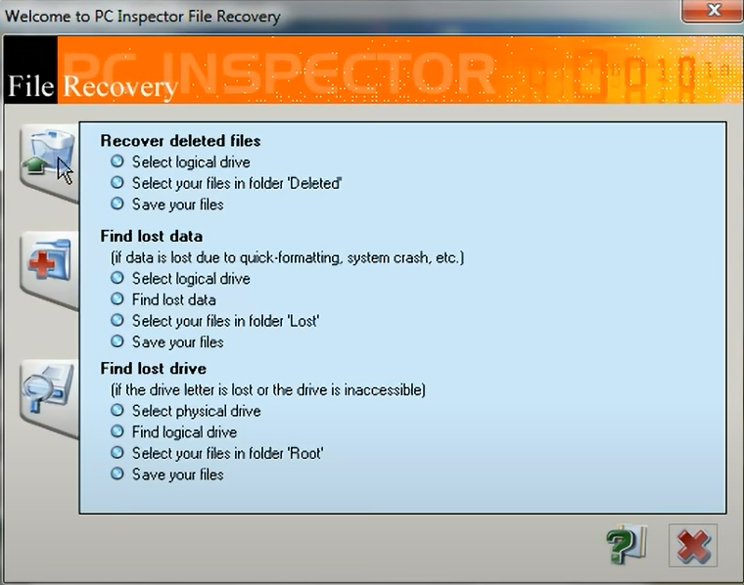

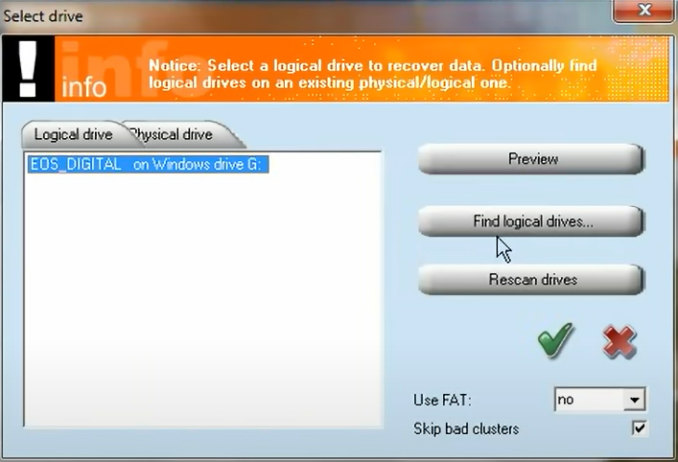

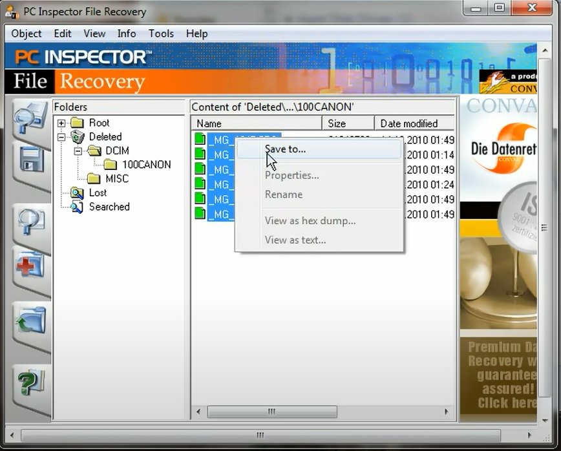

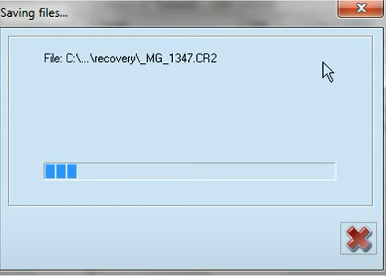

Recover data is saved to specified location

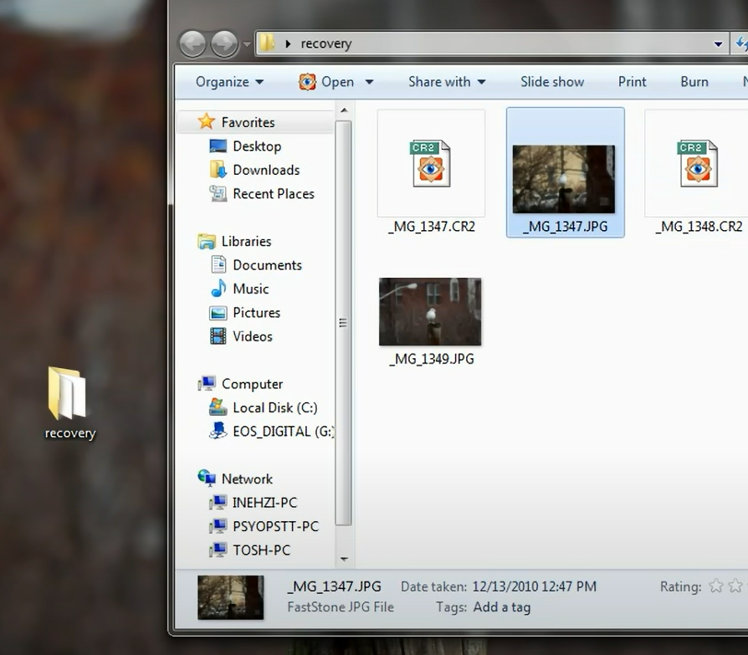

**Recover My Files**

**Download and install Recover My Files**

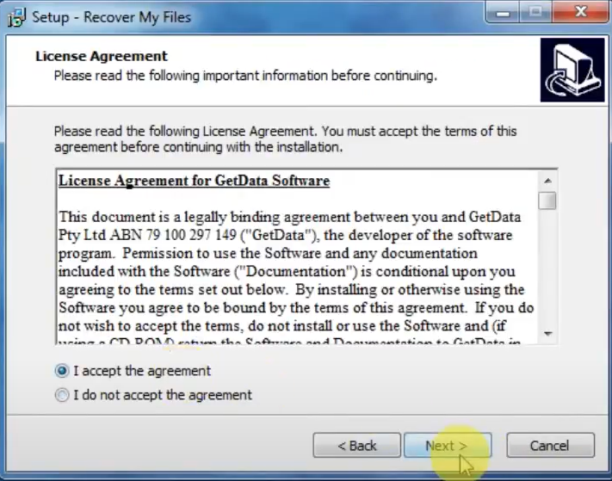

Select the option you wish to of Recover Files and Recover a Drive

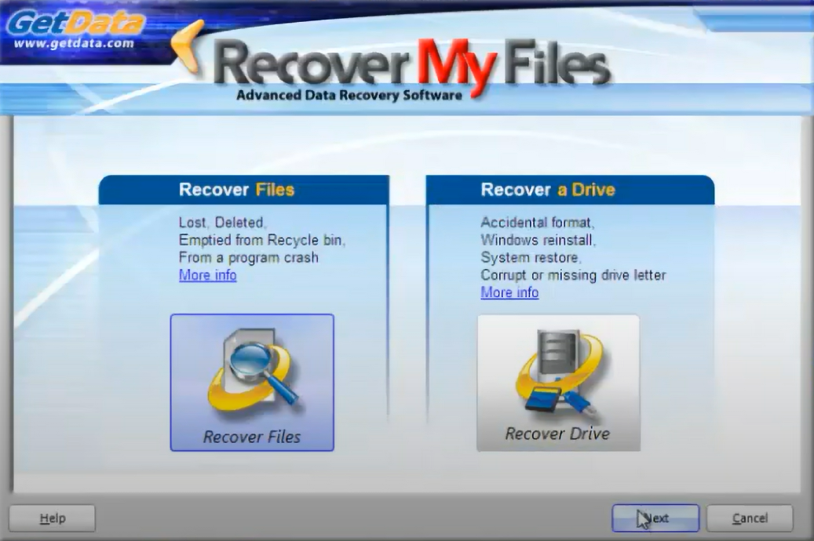

Select the drive to search and recover files & select one of the File Recovery options

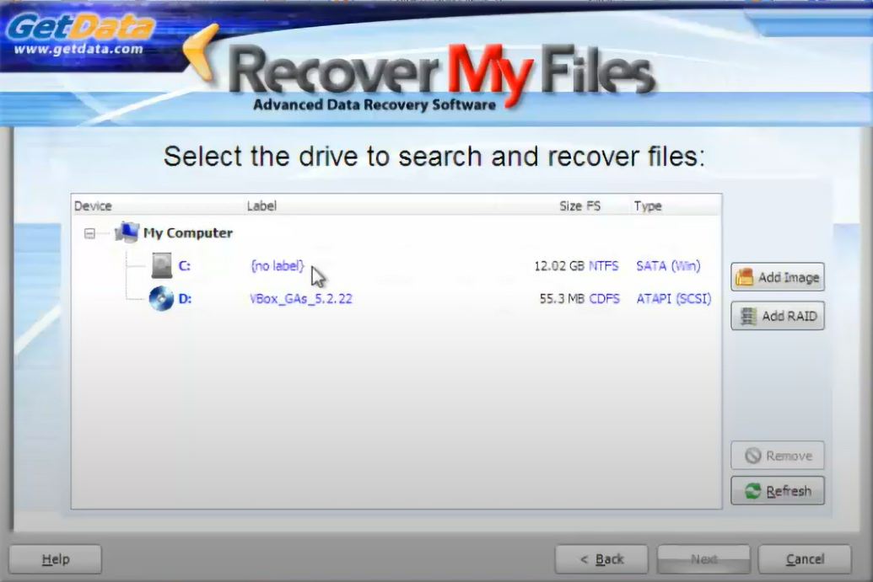

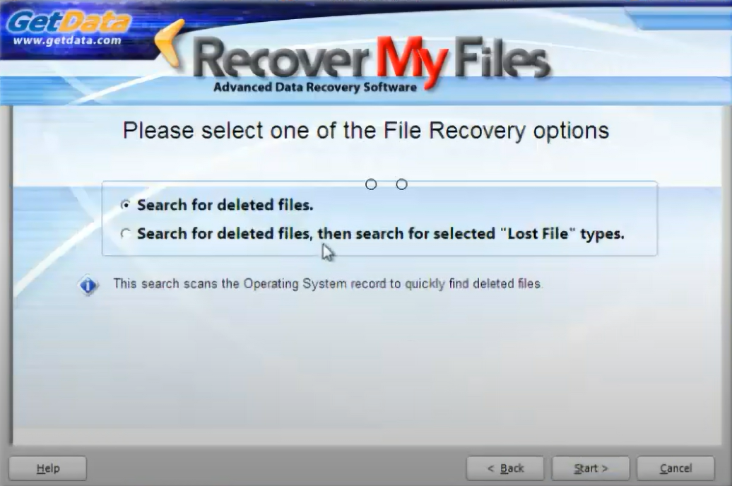

What file headers would like to search from recover files

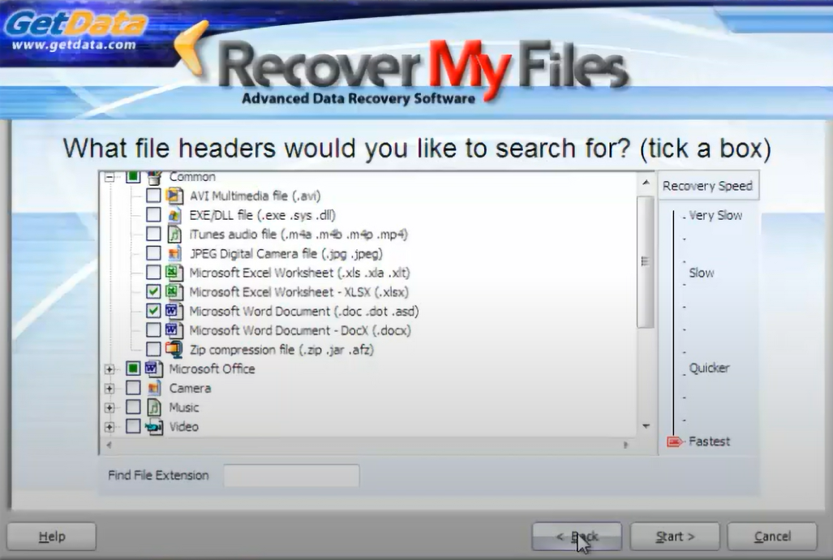

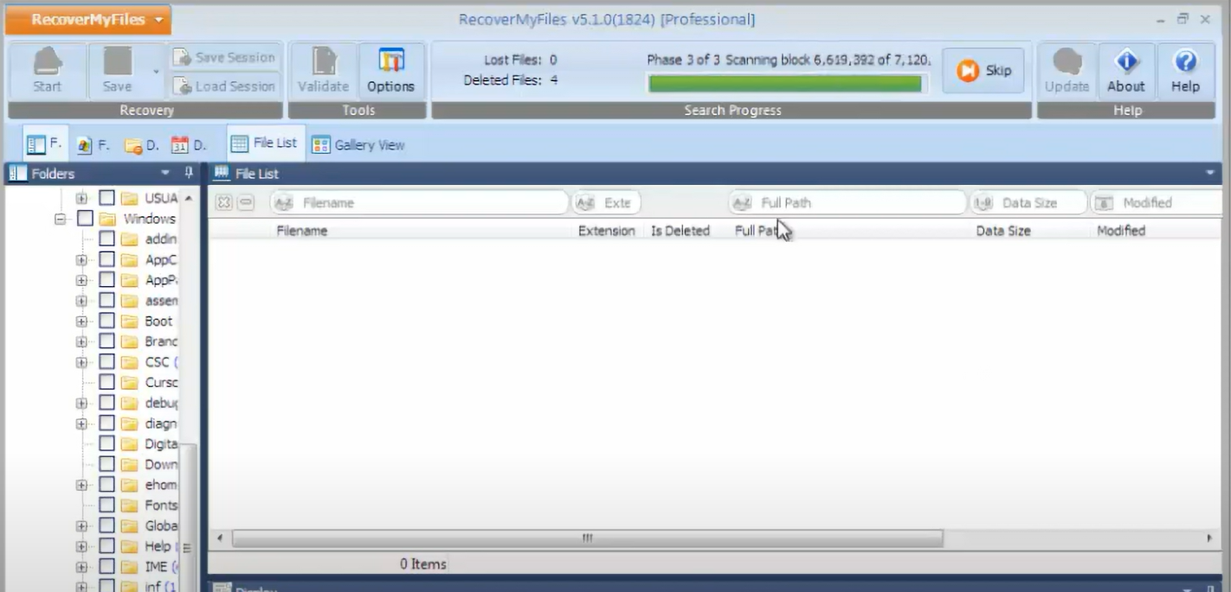

Scan and save the recovered file to desired location

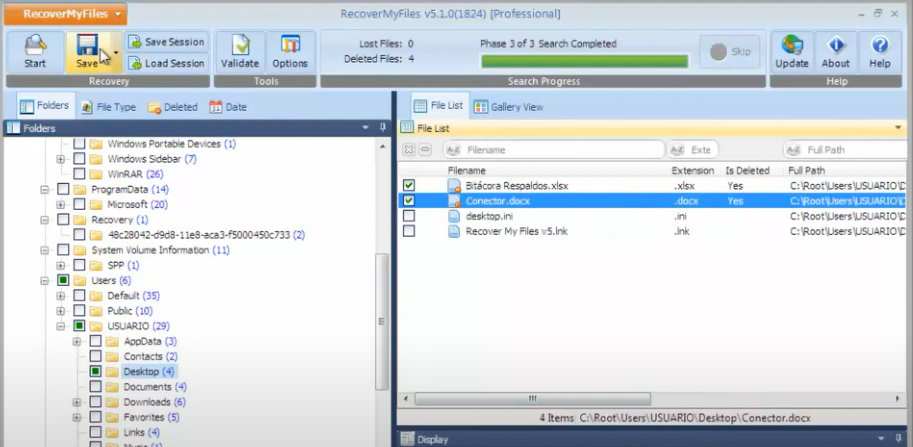

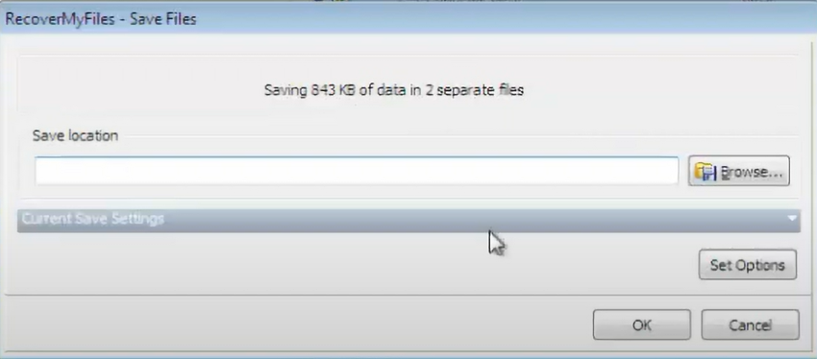

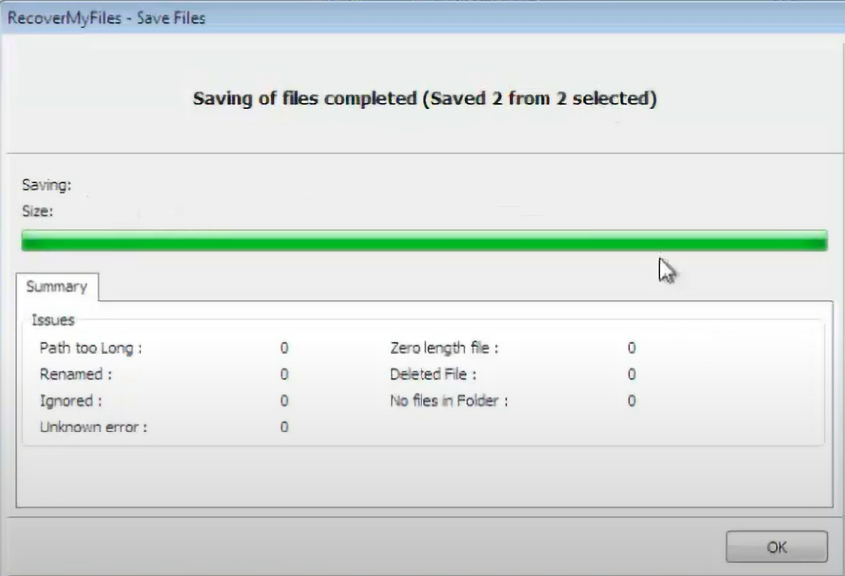

**PRACTICAL NO :05**

**a. Using Web attack detectiontools [Wireshark]**

1. Download and install wireshark

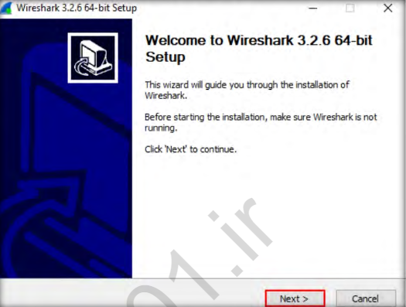

1. After completing the installation, navigate to C:\CHFI-Tools\EvidenceFiles\WiresharkSample Capture Files\Files for Network Forensics and double-click HTTP Traffic.pcapng.

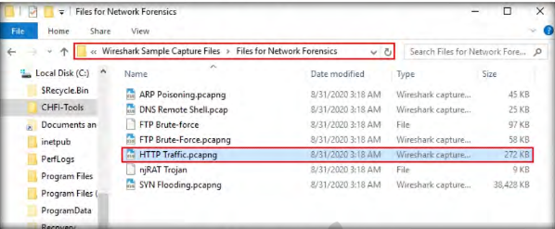

1. The above operation will launch the Wireshark GUI window and display the packets captured in HTTP Traffic.pcapng, as shown in the following screenshot

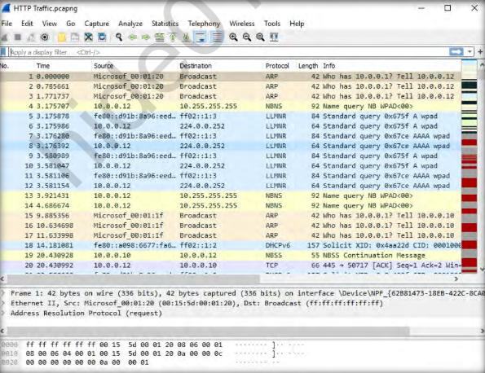

1. We will now apply the http filter so that the application displays results related to traffic generated through http. Type http in the Filter field and press Enter to filter the http traffic, as indicated in the screenshot below:

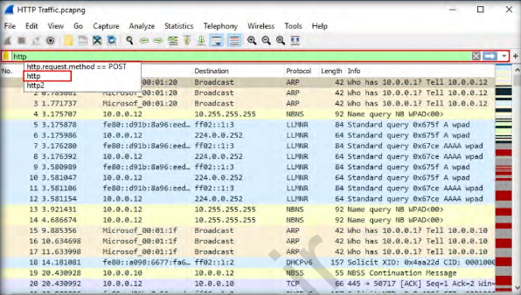

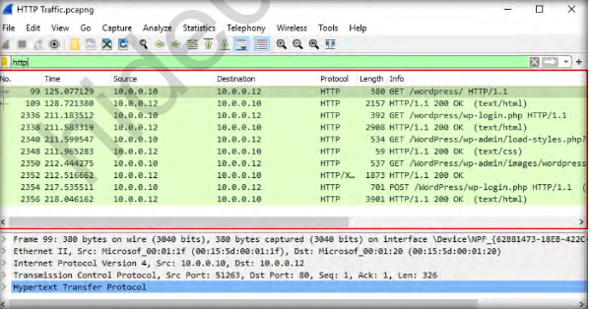

1. After examining the entries displayed by the application in the screenshot above, it is evident that the http traffic is associated with a WordPress website, and it is being transmitted in a plain text format. Generally, user credentials are stored in the POST requests. Therefore, examining packet(s) containing POST request can help an investigator find the user credentials.
2. We will now filter the traffic to obtain results specific only to POST request(s). **Now, type http.request.method== POST** in the Filter field and press Enter. Wireshark filters the traffic containing POST request(s) and displays them, as shown in the screenshot below. The user credentials stored in this request can be found under the Packet Details pane in the middle of the application window, under the HTML Form URL Encoded node.

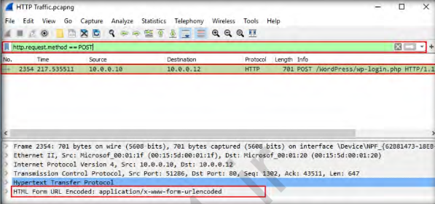

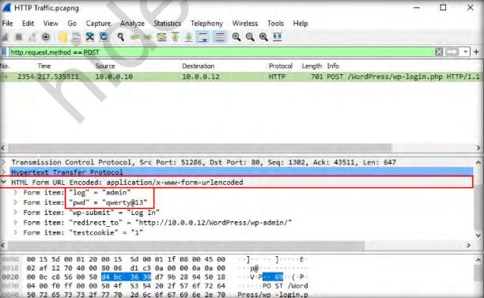

1. Now, navigate to C:\CHFI-Tools\Evidence Files\Wireshark Sample Capture Files\Files for Network Forensics and double-click DNS RemoteShell.pcapng.

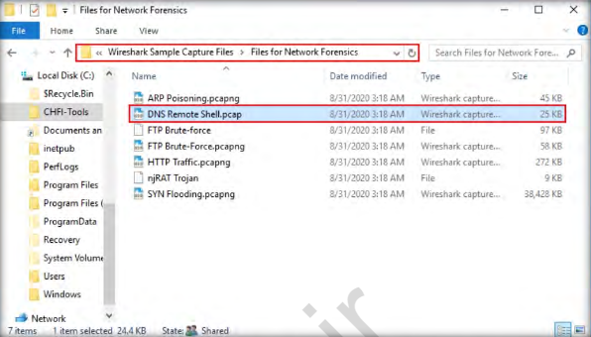

1. The network traffic entries captured in the DNS Remote Shell.pcapng file will now be displayed in the Wireshark GUI window, as shown in the following screenshot

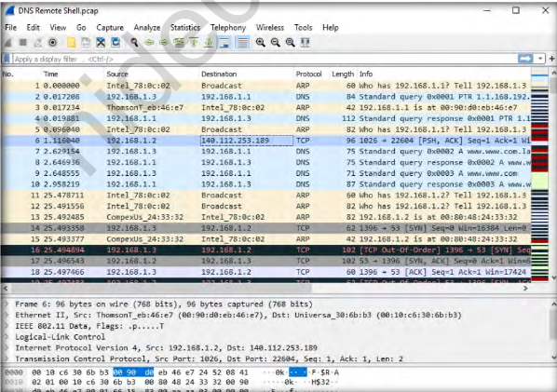

1. Since DNS uses port 53 for communicating with clients, we will be filtering the traffic flowing to and from port 53. To filter traffic flowing on port 53, type the command tcp.port == 53 in the Filter field and press Enter. Wireshark filters the traffic flowing on port 53 and displays it, as shown in the following screenshot

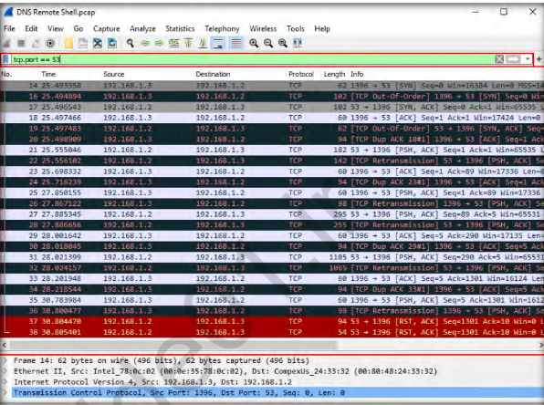

When we examine the first packet from the listed packets, i.e., Packet 14,we can see that Port 1396 on Source IP address (192.168.1.3) is trying to establish a remote connection with Port 53 on the Destination IP address(192.168.1.2) through a [SYN] request. As Port 53 is seen on 192.168.1.2,this IP address represents the DNS server here. When we examine Packet17, we see that the IP address 192.168.1.2, which is the DNS server, is responding with a [SYN, ACK] acknowledgment to IP address 192.168.1.3.Upon examining Packet 18, we see that the IP address 192.168.1.3 is sending an [ACK] acknowledgment to 192.168.1.2, thus establishing a remote connection with the target/victim (i.e., 192.168.1.2). From these observations, we can infer that 192.168.1.3 is the attacker’s IP address, which has succeeded in establishing a connection from its Port 1396 with Port 53 on the DNS server, as indicated through Packets 14, 17, and 18 in the screenshot below:

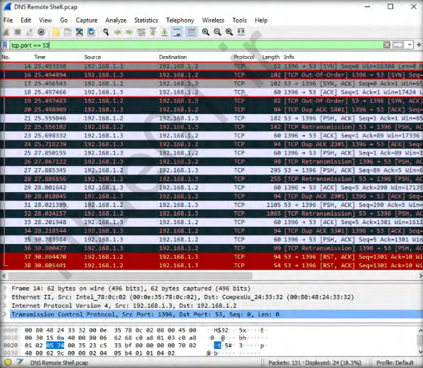

1. Right-click on any one of the packets from 14 to 38 (here, we have right-clicked on packet 14), select Follow from the context menu, and then click TCP Stream from the resultant drop-down list, as shown in the screenshot below:

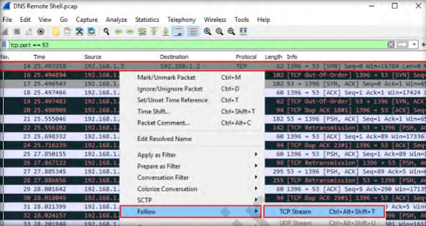

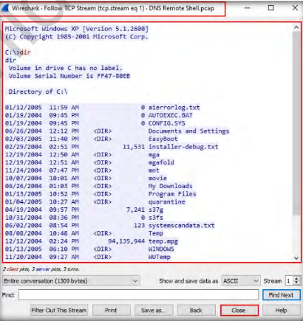

1. Now, we will look for FTP brute-force attempts in the network. Close the current packet capture file in Wireshark.

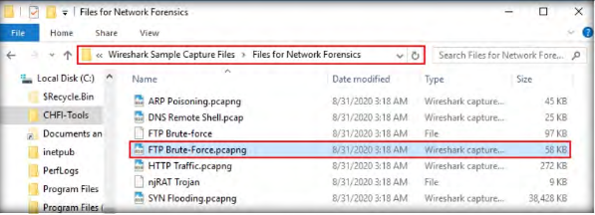

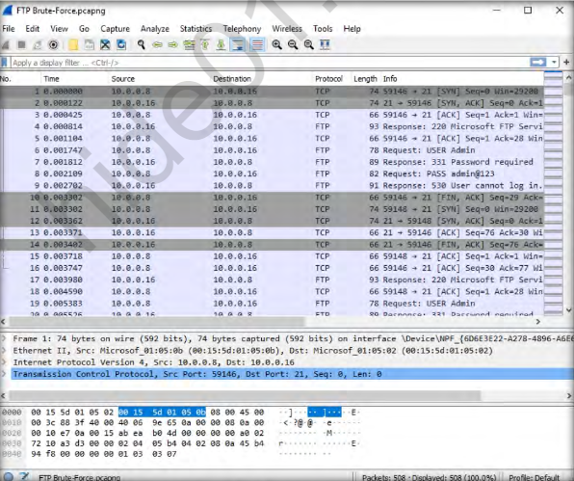

1. Apply **the ftp.response.code == 530** filter to monitor all unsuccessful login attempts over FTP. Upon applying the filter, the application will fetch results pertaining to unsuccessful login attempts, as shown in the screenshot below:

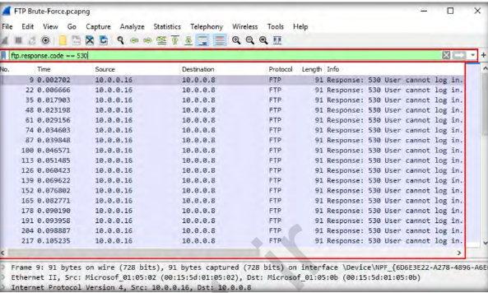

1. The screenshot above shows multiple unsuccessful login attempts madefrom the source IP 10.0.0.16 to the target IP 10.0.0.8, which stronglyindicates a brute-force attack.27. Apply the ftp.response.code == 230 filter to see successful logins on the FTP server. The application will fetch results that show successful logins from the source IP 10.0.0.16 to the target IP 10.0.0.8, as shown in the screenshot below. This indicates the attacker has successfully gained the victim’s login credentials

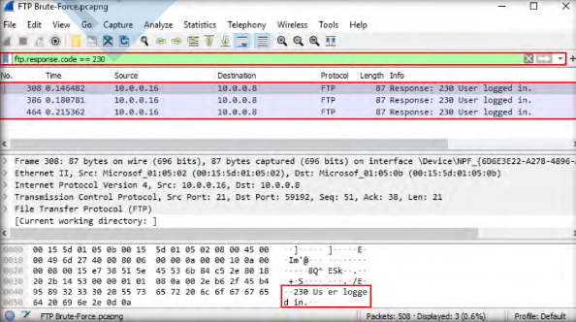

1. Now, we will look for ARP Poisoning attempt in the network.

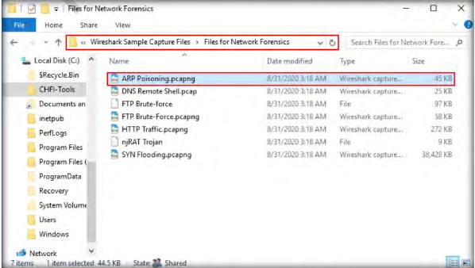

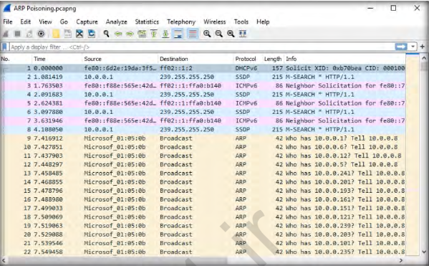

1. when ARP Poisoning has been attempted, Wireshark will detect duplicate IP addresses on the ARP protocol with the warning message Duplicate IP address detected for <IP address>. Therefore, we need to check if the use of a duplicate IP address has been detected.45. To locate a duplicate IP address in the traffic, apply the arp. duplicate-address-detected filter. Wireshark detects duplicate IP address on the ARP protocol with the warning message Duplicate IP address detected for 10.0.0.1, as shown in the screenshot below. The duplicated IP address can be seen both in the Packet Details pane in the middle of the application window and in its upper pane.

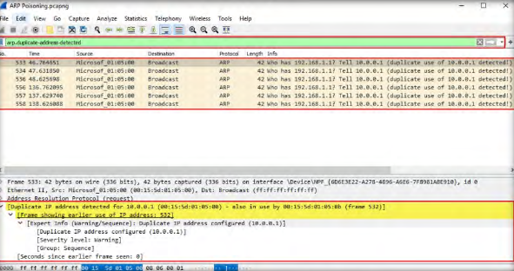

1. In this manner, you can analyze packet capture files that have recorded the traffic on a network as part of a forensic investigation.
2. **Using Log & Traffic Capturing & Analysis Tools [Wireshark]**

**Using Log Capturing and Analysis tools**

**Aim: Exploring Wireshark**

Wireshark is a network packet analyzer that intercepts, captures and logs information about packets passing through a network interface. This is useful for analyzing network problems, detecting network intrusions, network misuse, and other security problems, monitor usage and gather statistics, and many other applications.

### Filtering Packets

If you’re trying to inspect something specific, such as the traffic a program sends when phoning home, it helps to close down all other applications using the network so you can narrow down the traffic. Still, you’ll likely have a large amount of packets to sift through. That’s where Wireshark’s filters come in.

The most basic way to apply a filter is by typing it into the filter box at the top of the window and clicking Apply (or pressing Enter). For example, type “dns” and you’ll see only DNS packets. When you start typing, Wireshark will help you autocomplete your filter.

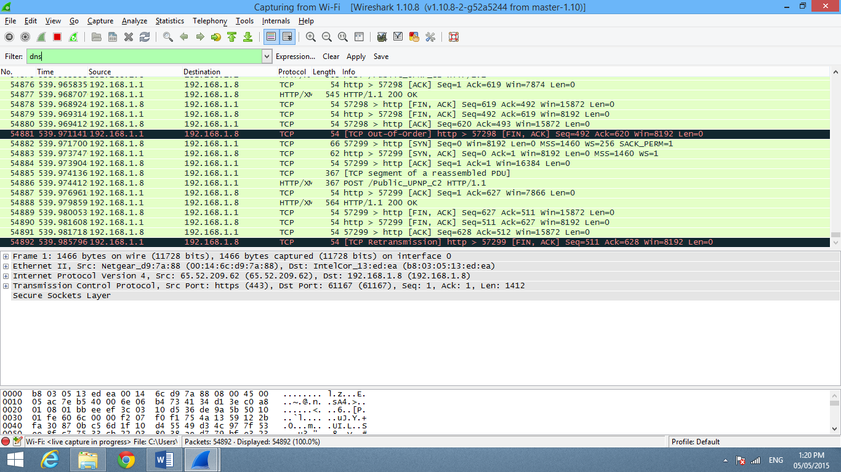

You can also click the Analyze menu and select Display Filters to create a new filter.

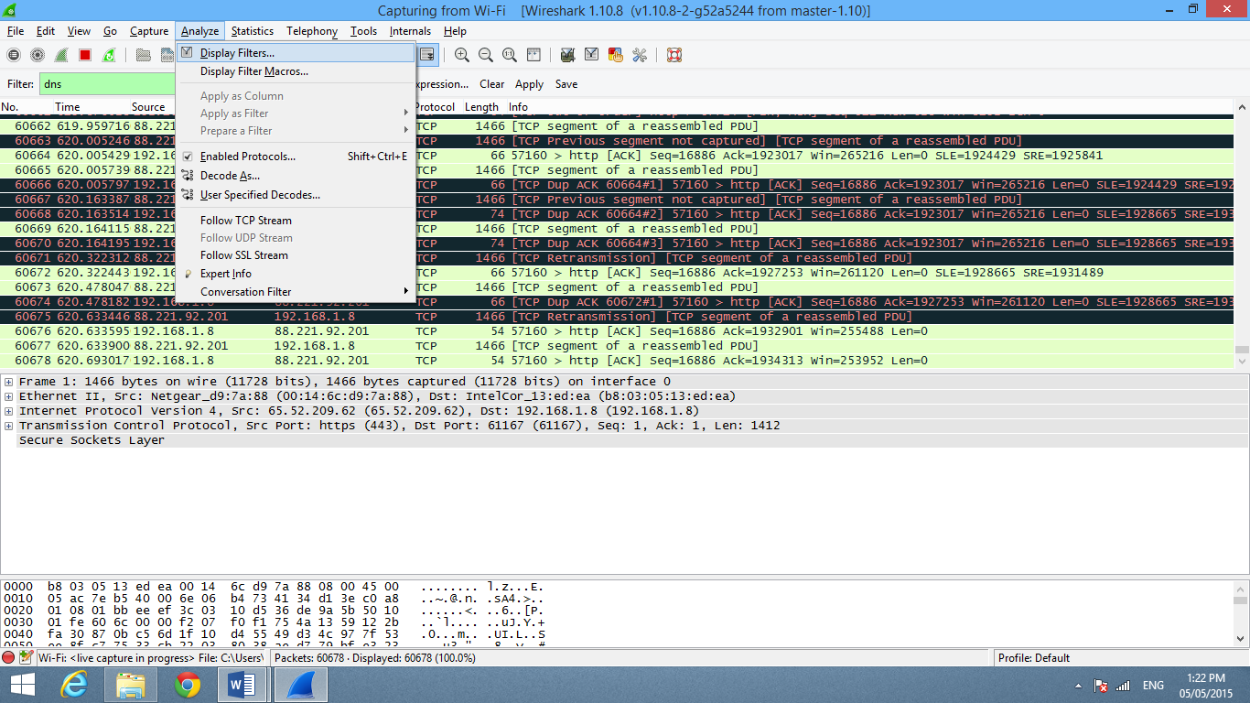

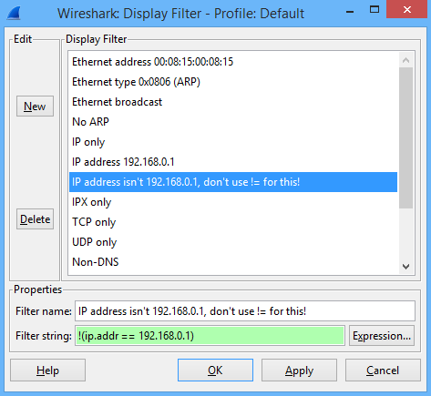

Another interesting thing you can do is right-click a packet and select Follow TCP

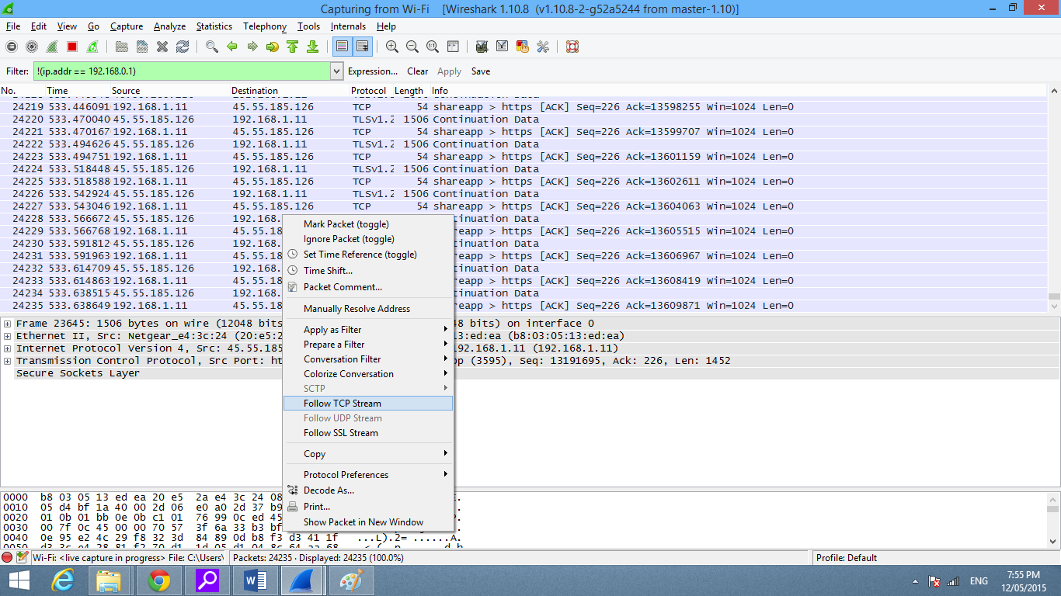

You’ll see the full conversation between the client and the server.

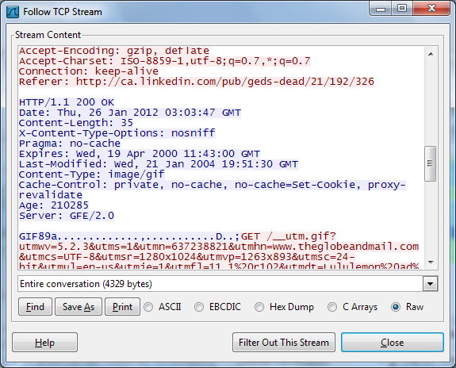

Close the window and you’ll find a filter has been applied automatically — Wireshark is showing you the packets that make up the conversation.

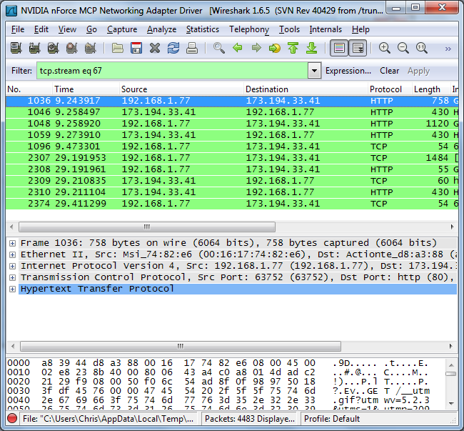

### Inspecting Packets

Click a packet to select it and you can dig down to view its details.

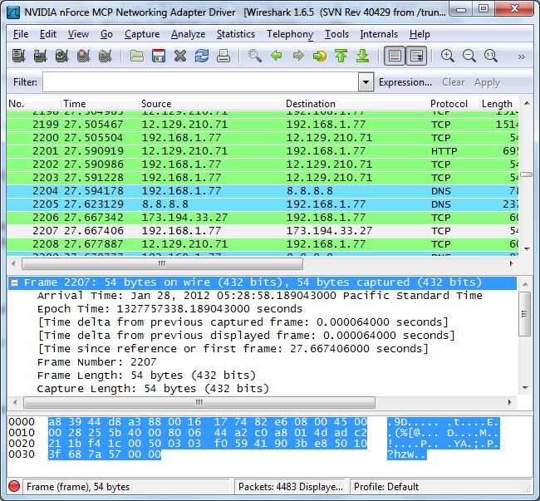  
  
You can also create filters from here — just right-click one of the details and use the Apply as Filter submenu to create a filter based on it.

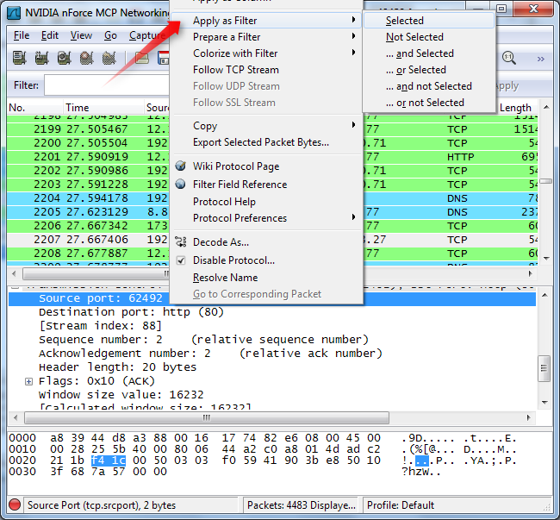

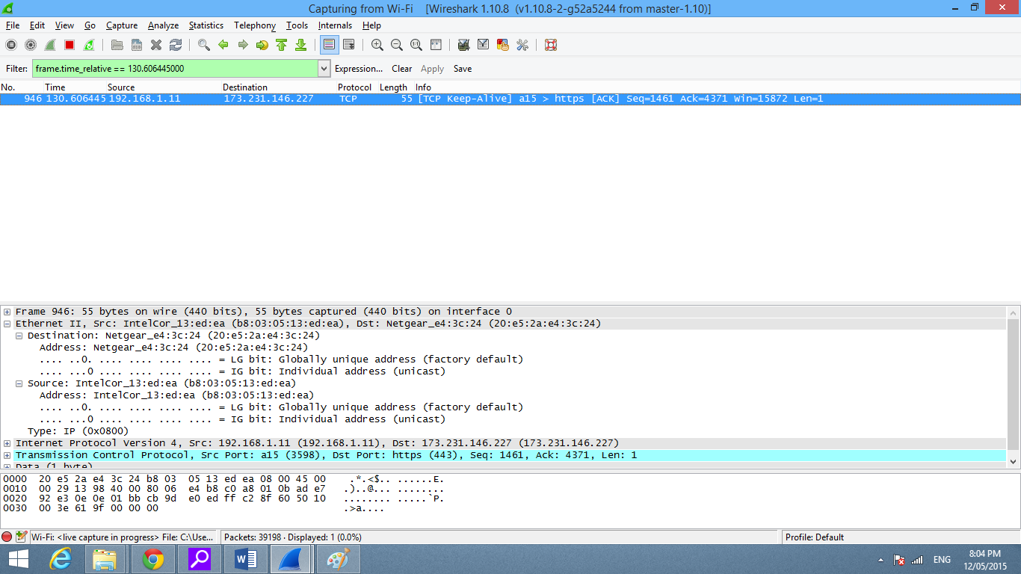

**Using Traffic Capturing and Analysis tools**

**Aim: Exploring Wireshark**

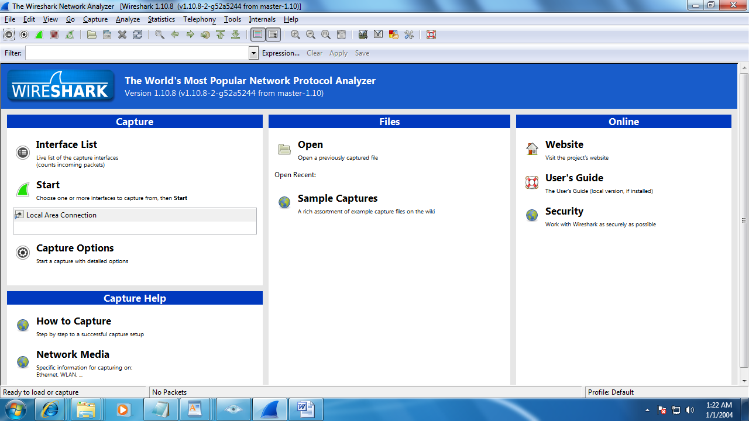

**Step 2**: On menu bar select Capture. Select interfaces.

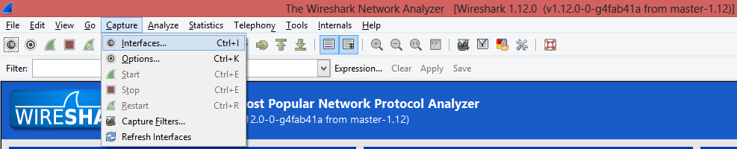

**Step 3:** Select Once you click on start, then Wireshark starts to capture the packets on that interface.

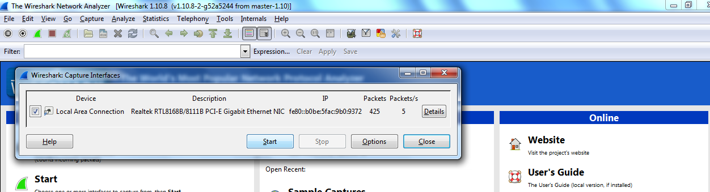

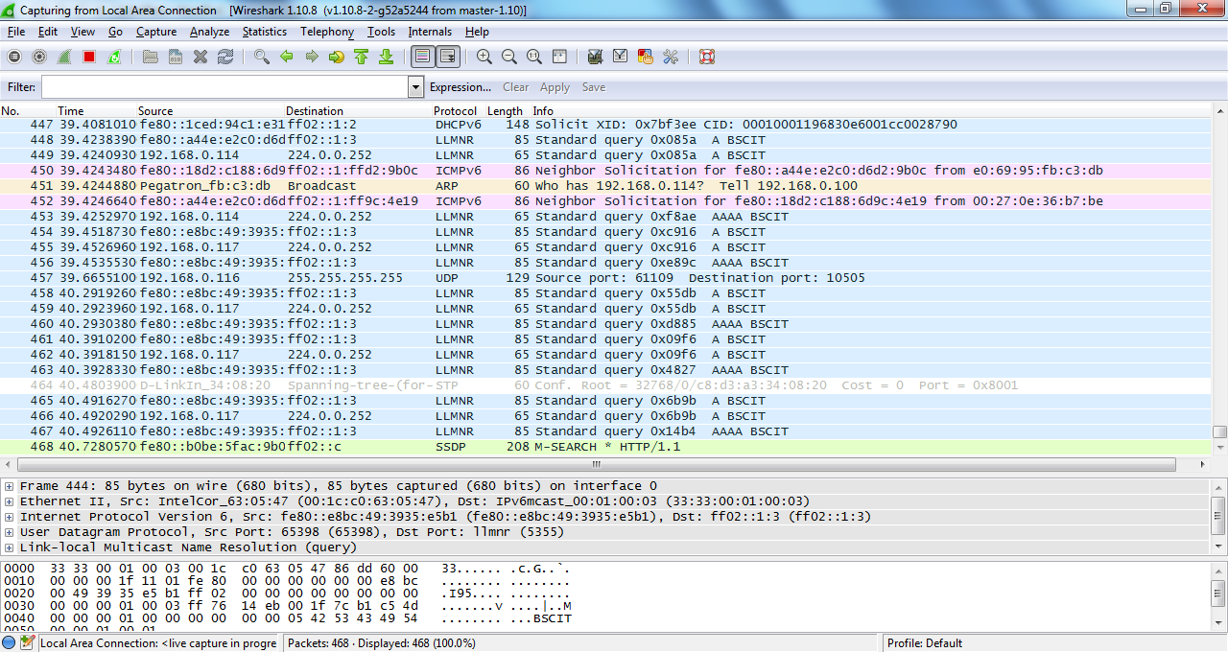

**Step 4**: Filter packets with HTTP protocol.

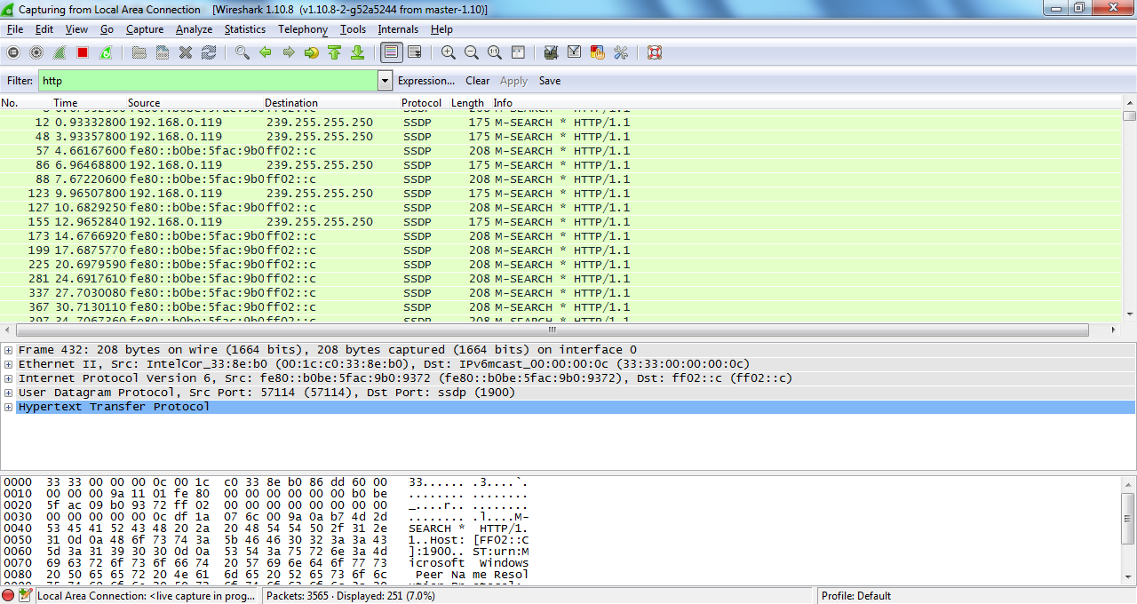

**Step 5:** A file with only text: <http://www.mu.ac.in/ppe/LIBRARY%20SCIENCE-(SEM.I)-SH-2014.pdf>

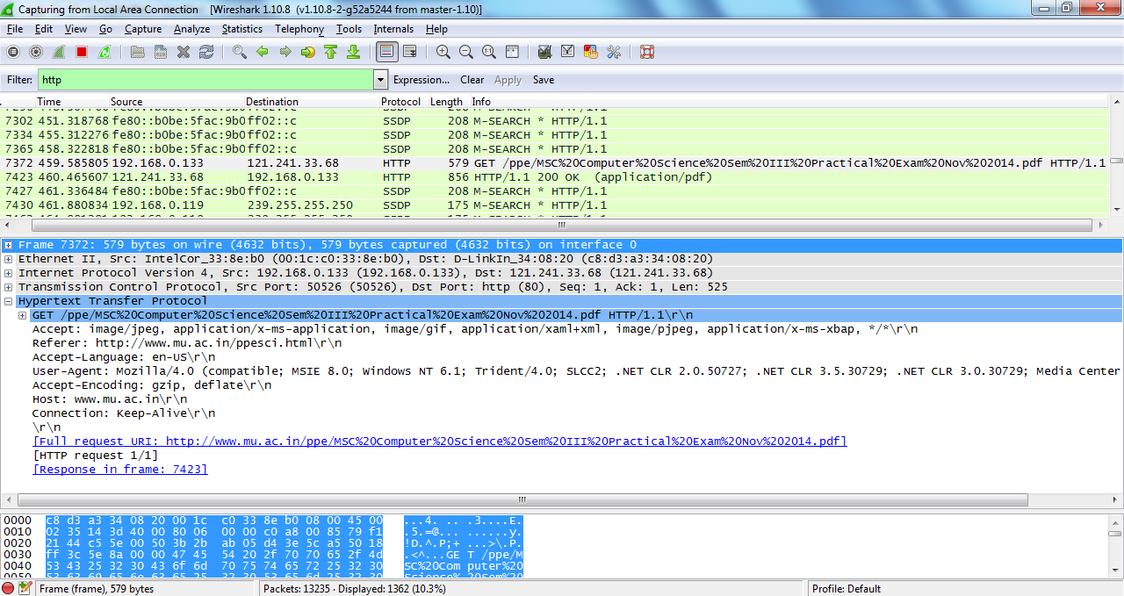

**Step 6**: Applying different filters using expressions.

1) Filtering HTTP POST request

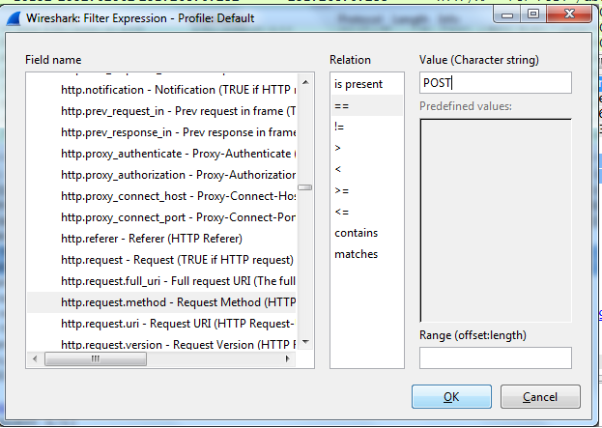

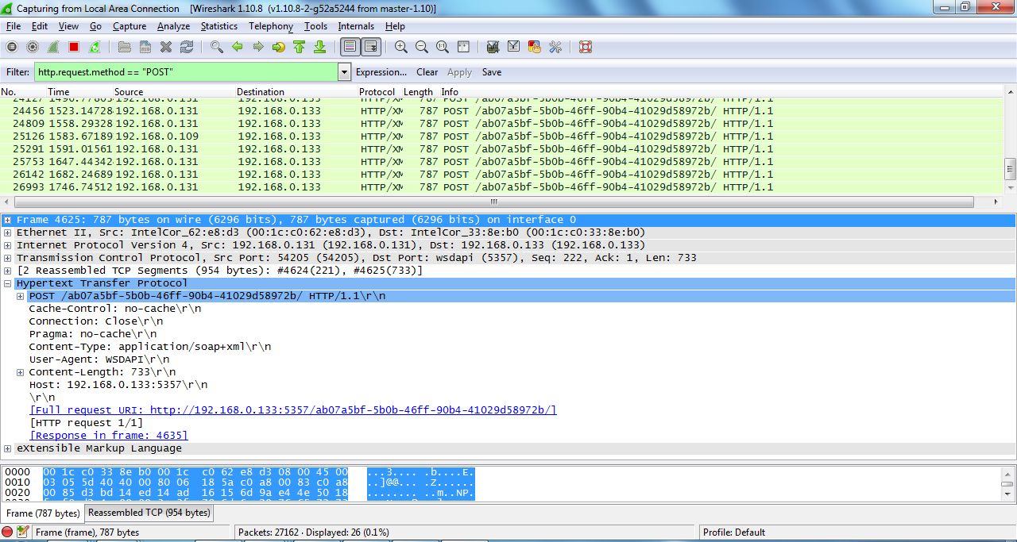

2) Filtering 404 not found error

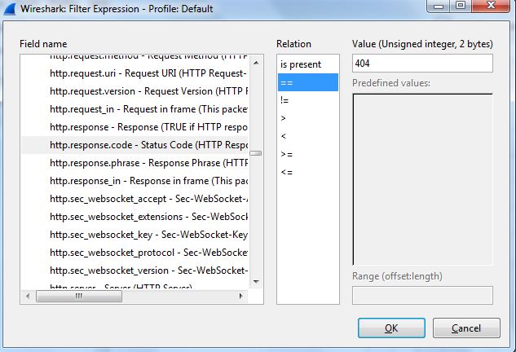

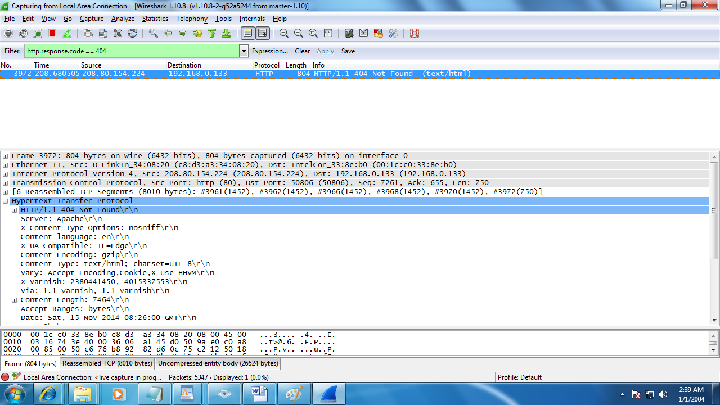

3) Filtering using HTTP Content Length

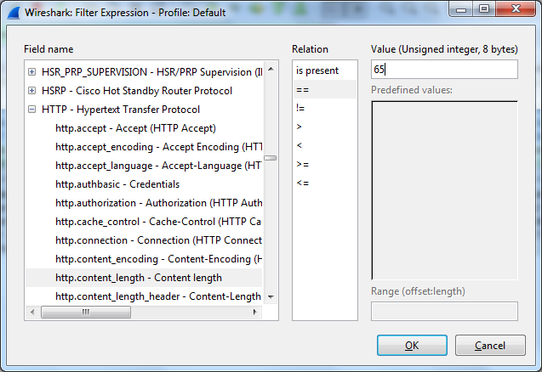

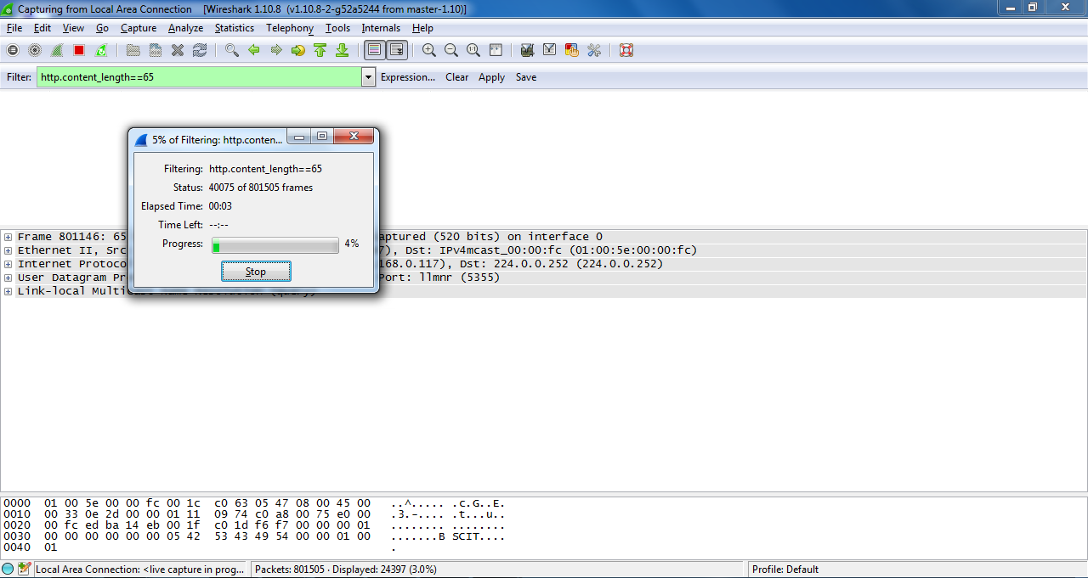

**PRACTICAL NO:06**

**Dump Memory contents using PMdump**

1. Here we will use program name mempass, and we will see how by using combination of pmdump and strings, we are able to dump the password in memory.

Let start the mempass

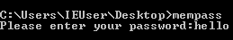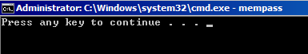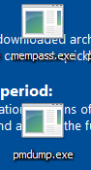

1. Now open new terminal and run PMdump, pmdump –list will list the running program currently.

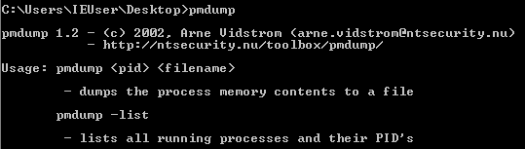

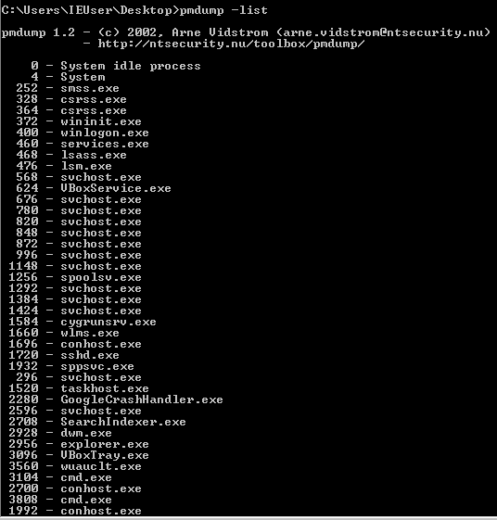

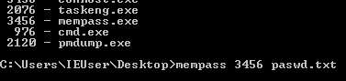

1. Here we can see the pid of mempass i.e., 3456. We will dump the entire memory of mempass program in paswd.txt file

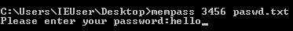

1. File name paswd is created having direct memory of mempass program without tampering the running mempass program

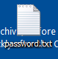

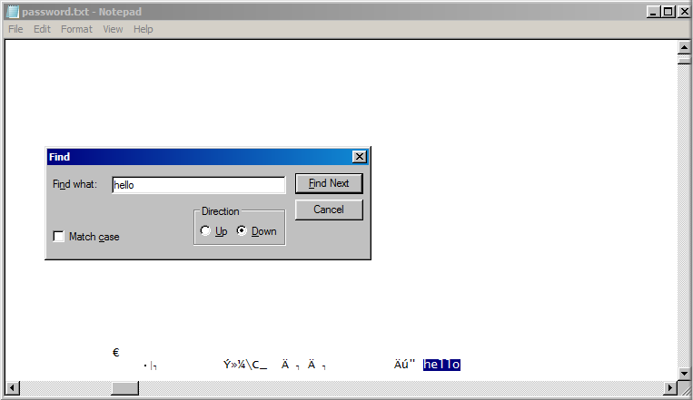

In this way, we can retrieve passwords from applications which store them in memory without any form of encryption.

**PRACTICAL NO:07**

**Using Data Acquisition Tools [ProDiscover Pro]**

Step 1) Start ProDiscover. ProDiscover presents the launch dialog.

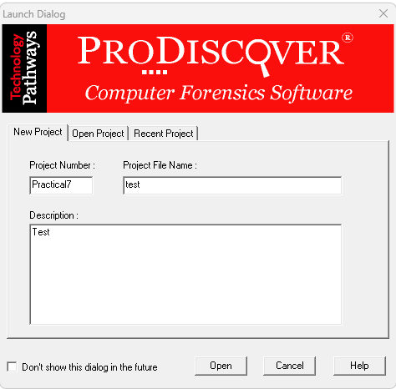

Step 2) Enter a project number, project name, and description of the project in the new project tab option, and then click the Open button. ProDiscover will then create a project and generate a template report in the work area.

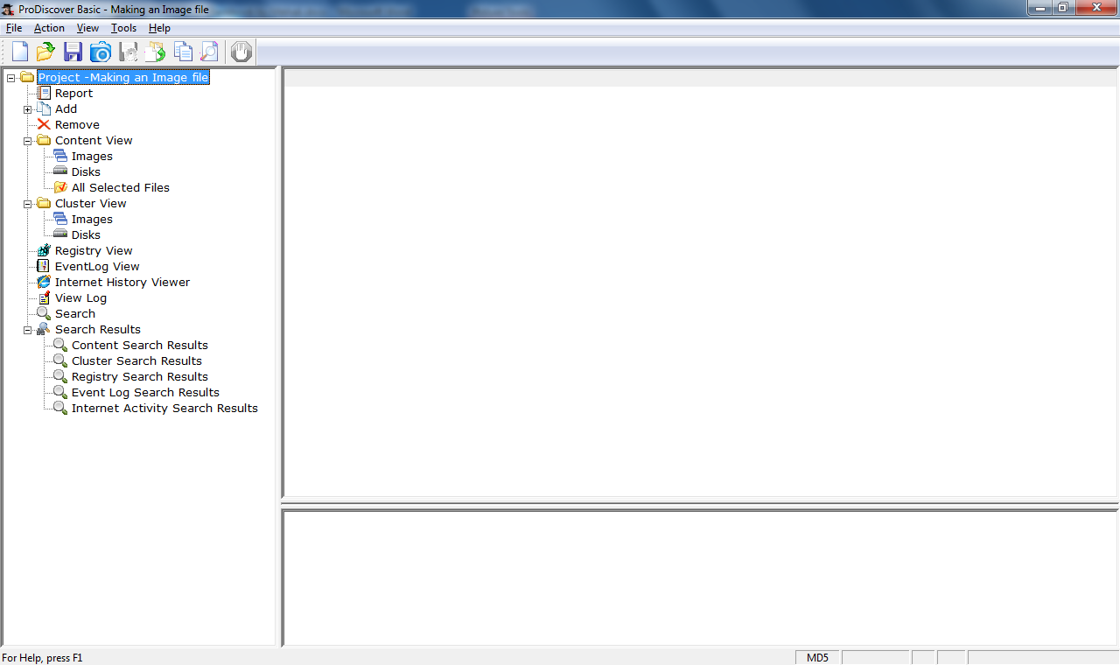

Step 3) Open Image:

1] Select save project option from the file menu, or button bar and Open Image option.

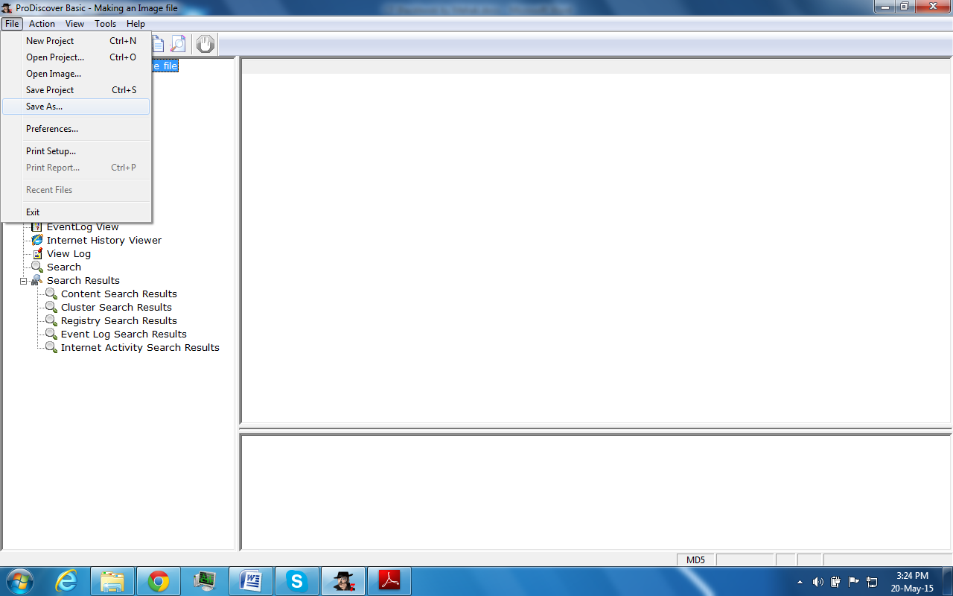

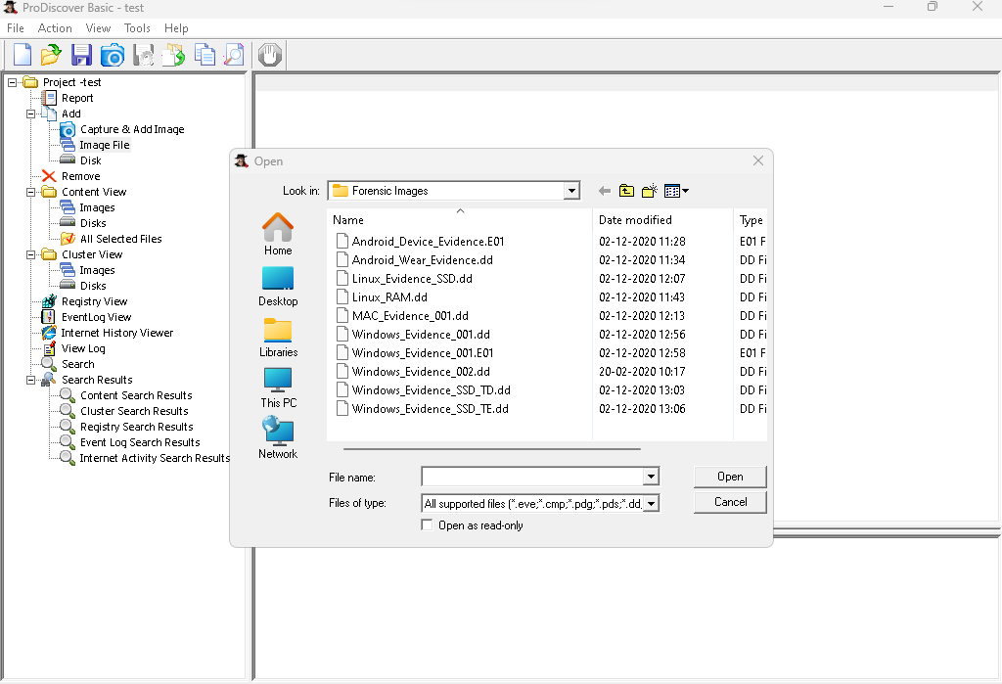

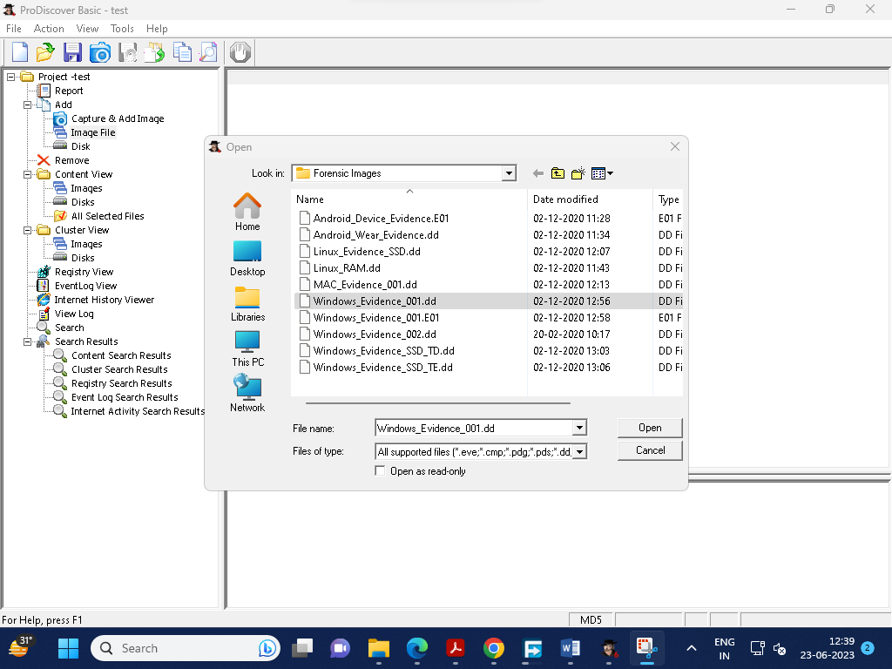

Step 4) ProDiscover displays the contents of the selected file at the bottom of the main window. **Right click** on a file.

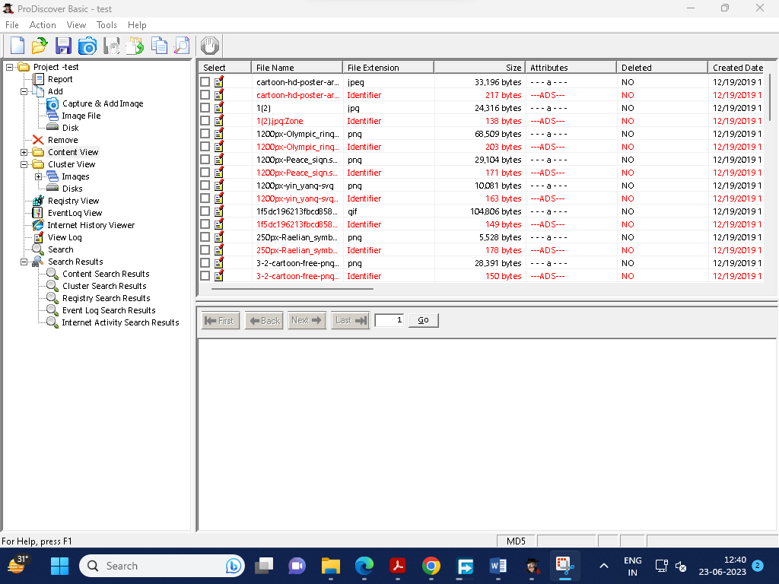

Step 5) In ProDiscover a pop-up dialog with the choice to View or Recover the selected file. Select **View**

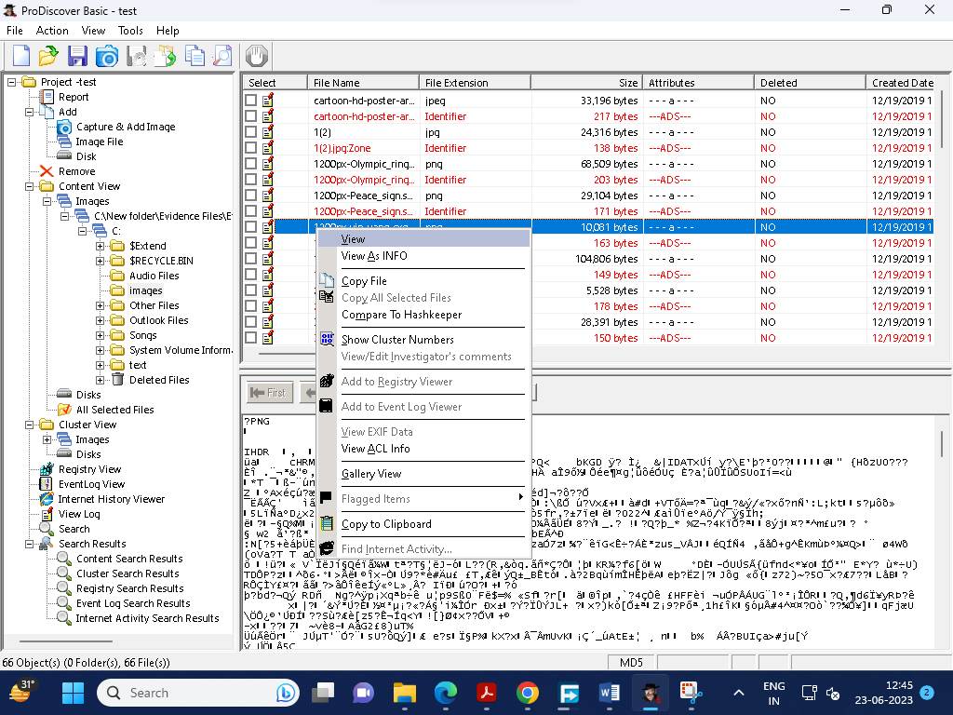

Step 6)For further study, we can also copy the file at desired location

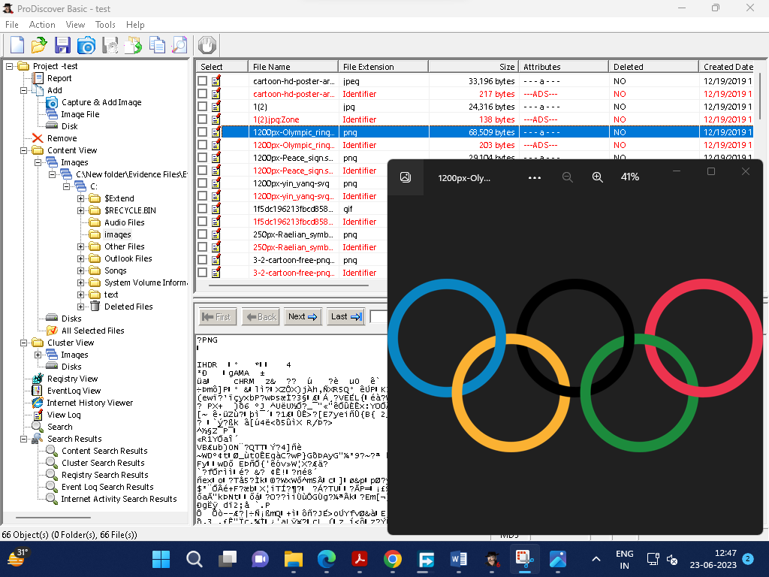

**PRACTICAL NO:08**

1. **Using Steganography Tools [S-Tools]**

Following steps Show how to use freeware S-Tools utility to hide and reveal files inside pictures

Step 1) Select the S-Tools.exe file and open the steganography software tool.

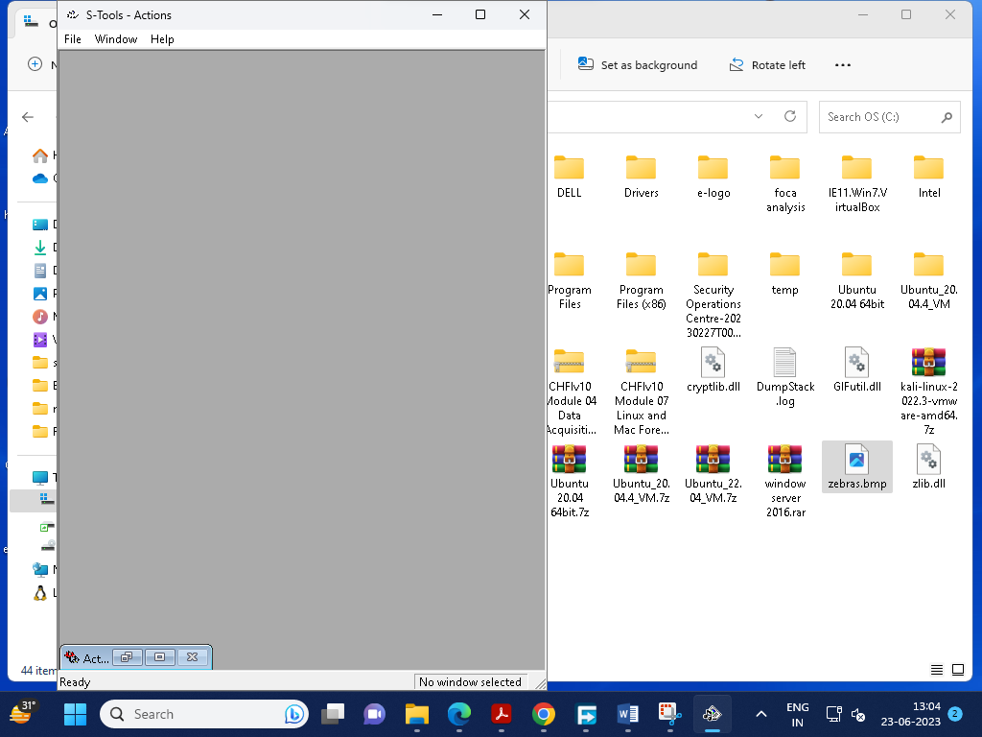

Step 2) With both the working directory and the S-Tools program open minimize both windows and place side-by-side.

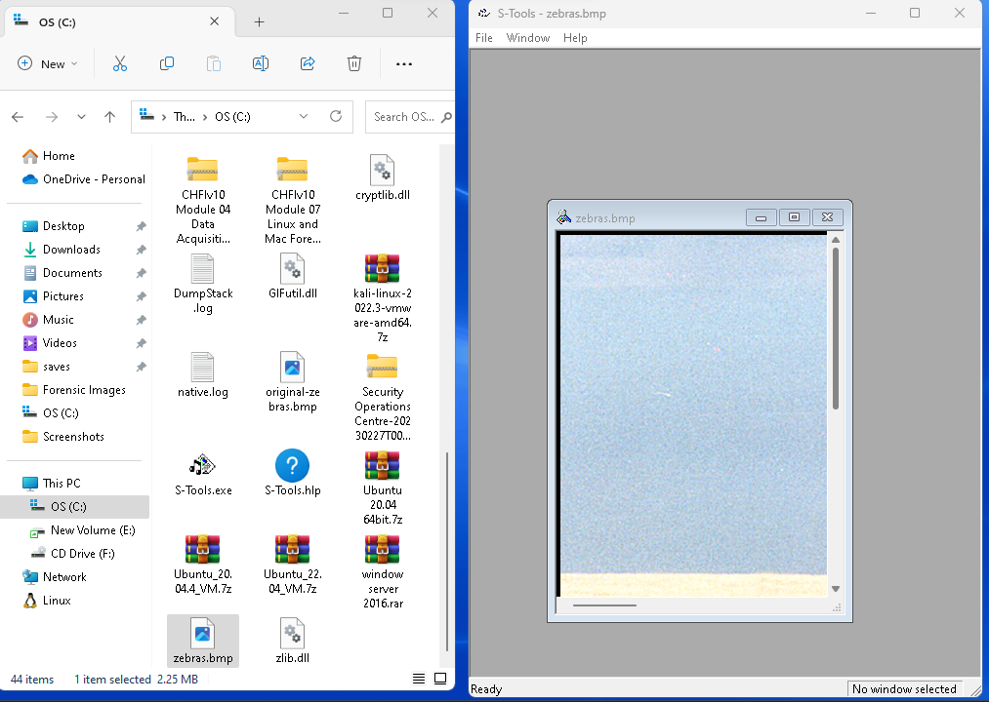

The S-Tools program is a drag and drop software. The files used to create the steganography file can be dragged from the directory into the S-Tools program.

Step 3) Select the file from the directory and drag it over the S-Tools main window and release the file.

A dialogue box appears indicating that the file type is unknown. Supported file types for audio and image files are shown below:

* Audio - *.wav
* Image - *.bmp and *.gif

If your image is in .jpg format, convert it to .bmp format.

Step 4) Select a file to hide within the base file. If it’s not there, create a txt file and save the file. Here we have created file name Hidden file

Step 5) The *.txt text file is selected and dragged on top of the base image. Release the file while the cursor is still on top of the base file.

Step 6) A dialogue box will appear asking the user to enter and verify a passphrase. Additionally, the user will have to select an encryption algorithm.

Step 7) Select the ‘OK’ button after entering a valid passphrase.

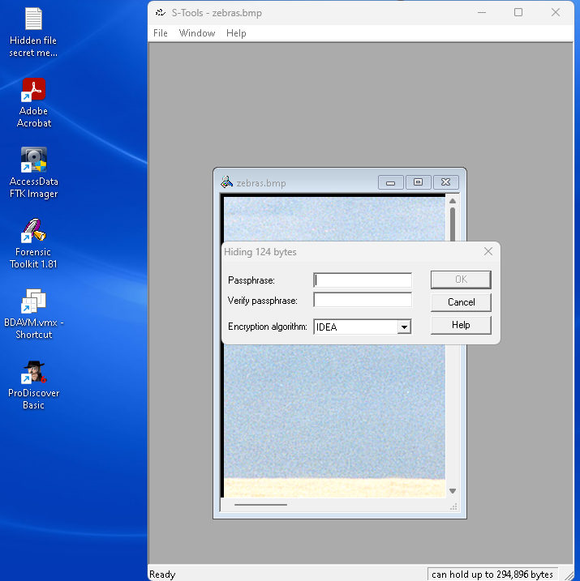

Step 8) The S-Tools main window will appear and a new file will be visible. The name of the file will be called hidden data by default.

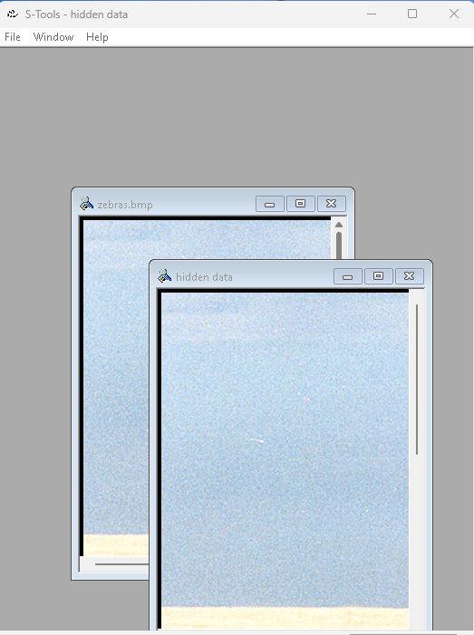

Step 9) Place the cursor on top of the hidden data image and select the right mouse button. The user will have four options available to them:

* Save
* Save As
* Properties
* Reveal

Select the ‘Save As’ button.

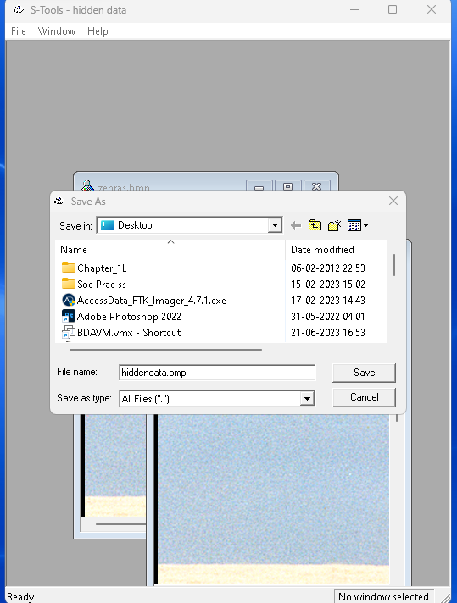

Step 10) A ‘Save As’ dialogue box will appear. Enter a valid file name, select the working directory and select the ‘Save’ button.

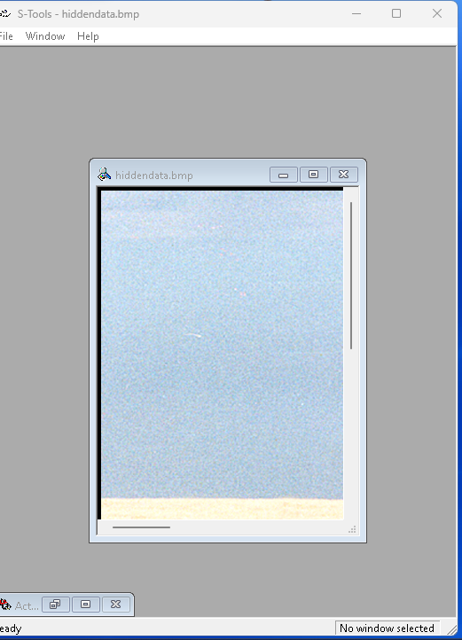

Step 11) Selecting the ‘Reveal’ button will display a passphrase dialogue box. A passphrase must be entered twice in the dialogue box and the correct encryption algorithm must be selected.

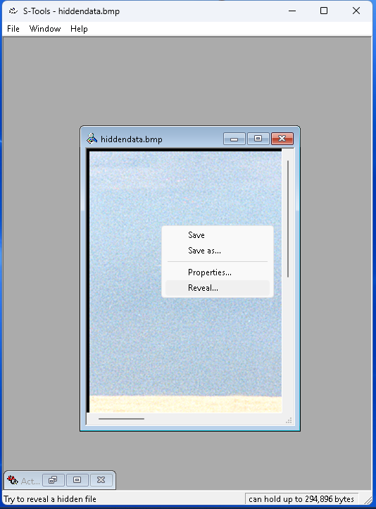

Step 12) Enter a passphrase twice, select the encryption algorithm, and select the ‘OK’ button.



Step 13) A ‘Revealed Archive’ dialogue box will display which contains the file name and size of the hidden file.



Step 14) Select the ‘Save As’ button.

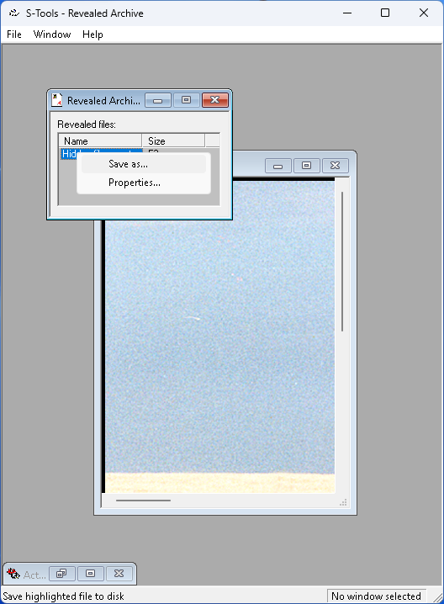

Step 15) The Revealed data is saved in revealfile.txt

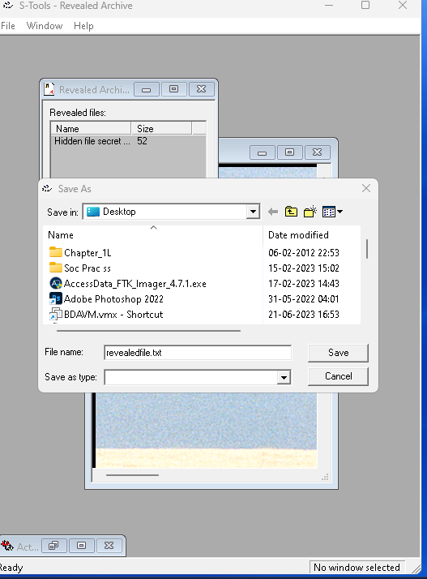

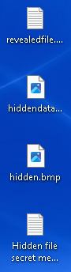

1. **Using Whitespace Stegnography tool SNOW**

Step 1) Create a text file with some data in the same directory where Snow Tool is installed.

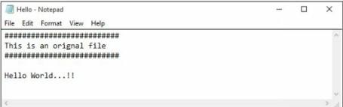

Step 2) Go to Command Prompt

Change the directory to run Snow tool

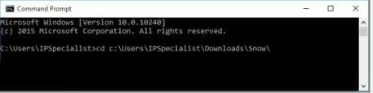

Step 3) Type the command

**Snow –C –m “text to be hide” –p “password” <Sourcefile> <Destinationfile>**

The source file is a Hello.txt file as shown above. Destination file will be the exact copy of source file containing hidden information.

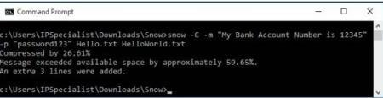

Go to the directory; you will a new file **HelloWorld.txt**. Open the File

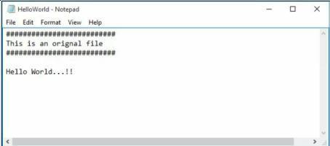

Step 4) New File has the same text as an original file without any hidden information. This file can be sent to the target.

### Recovering Hidden Information

On destination, Receiver can reveal information by using the command

**Snow –C –p “password123” HelloWorld.txt**

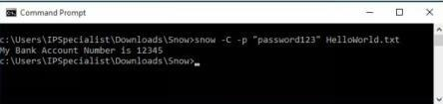

As shown in the above figure, File decrypted, showing hidden information encrypted in the previous section.